[](http://www.calstatela.edu/centers/hipic) **CIS5900 Term Project Tutorial**

#### Authors: [Monika Mishra](https://www.linkedin.com/in/monika-mishra-8b2a4115/)

#### Instructor: [Jongwook Woo](https://www.linkedin.com/in/jongwook-woo-7081a85)

#### Date: 08/10/2019

**Lab Tutorial**

Monika Mishra [(mmishra2@calstatela.edu)](mailto:(mmishra2@calstatela.edu))

08/10/2019

**Drug Review Analysis Using Elasticsearch and Kibana**

**Objectives**

**List what your objectives are.** In this hands-on lab, you will learn how to :

* Start the Elasticsearch and Kibana server
* Upload the data in Elasticsearch using Kibana
* Make changes in the mapping
* Create visualization in Kibana using **Visualize** and **Canvas** feature
* Detect anomaly and forecast using **Machine Learning**

**Platform Specification**

* Elasticsearch Version Number : 7.2.0

Number of Node : 1

Disc Size : 456.6 GB

* Kibana Version : 7.2.0

Memory Size : 1.4 GB

* OS : Mac OS X

Processor Speed: 3.1 GHz

Number of Processor: 1

Number of Cores: 2

Memory: 8 GB

**Steps followed for the analysis :**

1. Data Acquisition and Pre-Processing
2. Uploading the data and making changes in the mapping
3. Visualization
4. Anomaly detection and forecasting

**Data Acquisition and Pre-Processing**

1. Download the dataset from UCI ML repository : <https://archive.ics.uci.edu/ml/datasets/Drug+Review+Dataset+%28Drugs.com%29>

The dataset is of TSV format.

1. The dataset has a date column with no timestamp. To use Machine Learning in Kibana, at least one column with timestamp is needed. So, the date field needs to be formatted to include the timestamp. Open the file with MS Excel and format the time column as below:

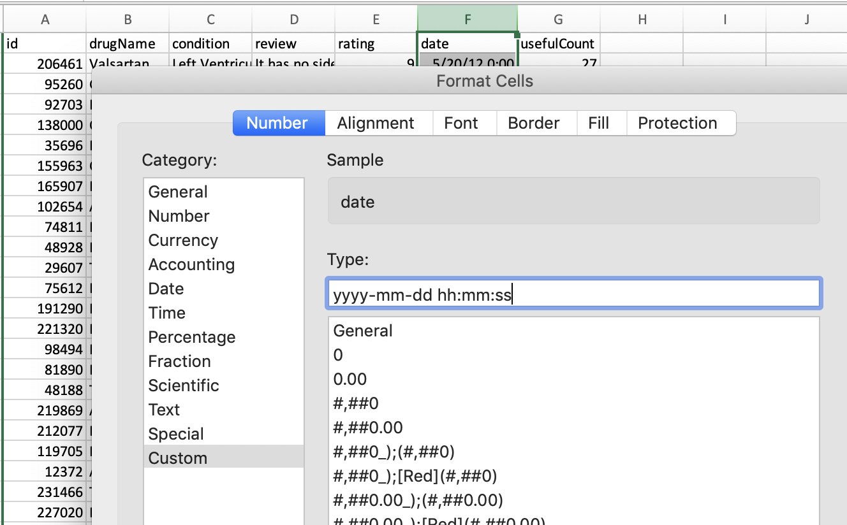

1. Save the file in **CSV** format as **drugs.csv**.

**Starting the Elasticsearch and Kibana server**

1. Open a terminal and go to the directory where Elasticsearch is installed. Start the Elasticsearch engine by running the below commands:

|  |
| --- |
| cd elasticsearch-7.2.0  ./bin/elasticsearch |



1. It will take few seconds to start the Elasticsearch. Once it is started, you can check if it’s working or not by entering the URL in the browser :

|  |
| --- |
| <http://localhost:9200/> |

It will display similar to the following:

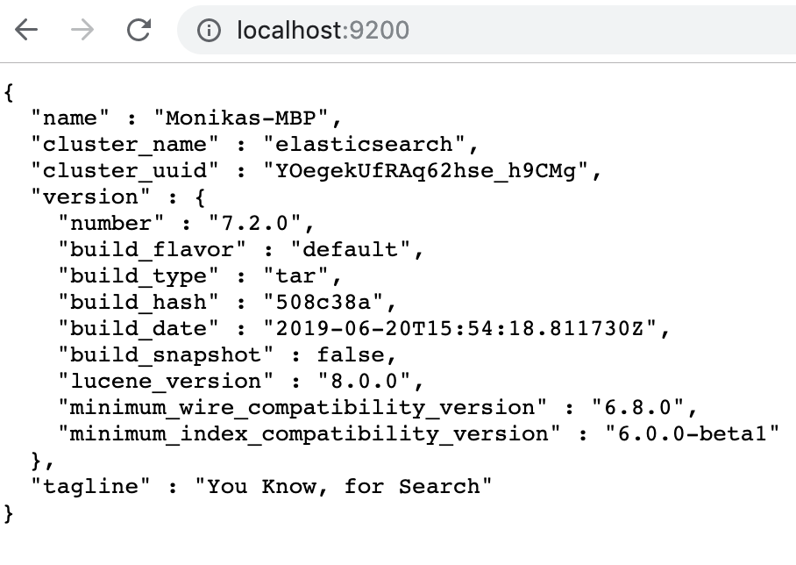

1. Open another terminal and go the directory where Kibana is installed. Run the following commands:

|  |
| --- |
| cd kibana-7.2.0-darwin-x86_64  bin/kibana |

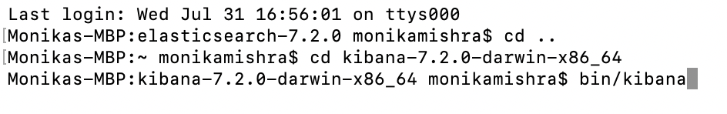

1. It will take few seconds to start the Kibana. Once it is started, you can open the Kibana by entering the following URL in the browser :

|  |
| --- |
| http://localhost:5601 |

The Kibana homepage will be displayed.

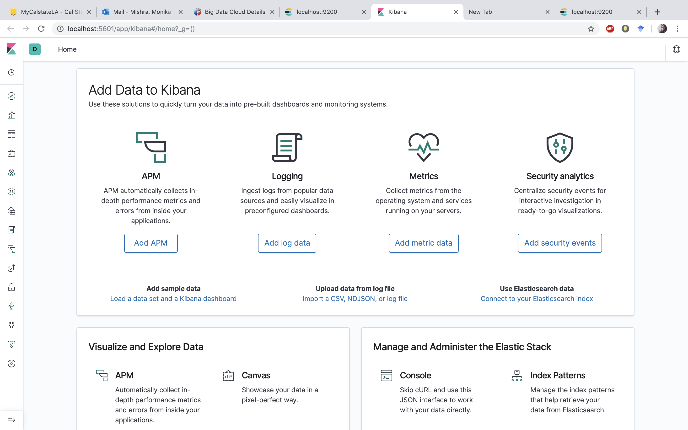

**Uploading the Data and Mapping Changes**

In the Visualize and Canvas application, you can shape your data using a variety of charts, tables, and maps, and more.

* 1. Click on **Upload data from log file** as shown above.
  2. Upload the csv file and click on **Import**.

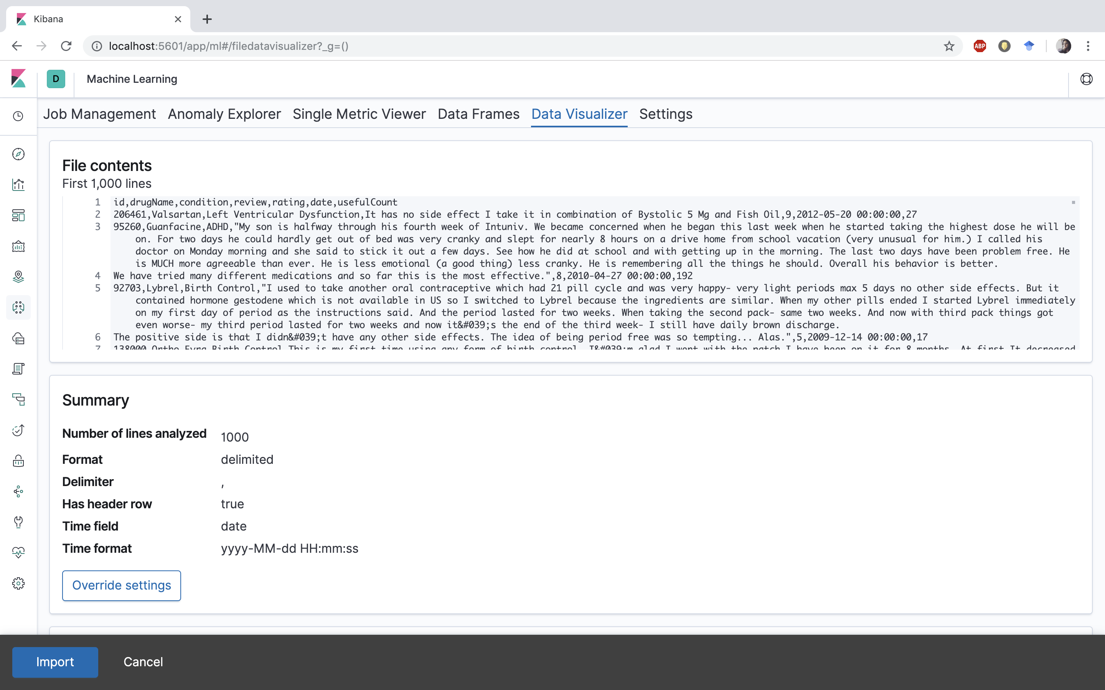

* 1. Go to **Advanced** tab. Enter **drugs** as **Index name** and **Index pattern name**.
  2. In the Mappings field, the **type** for **drugName** and **review** is mentioned as “**text**”. Change it to “**keyword**”.

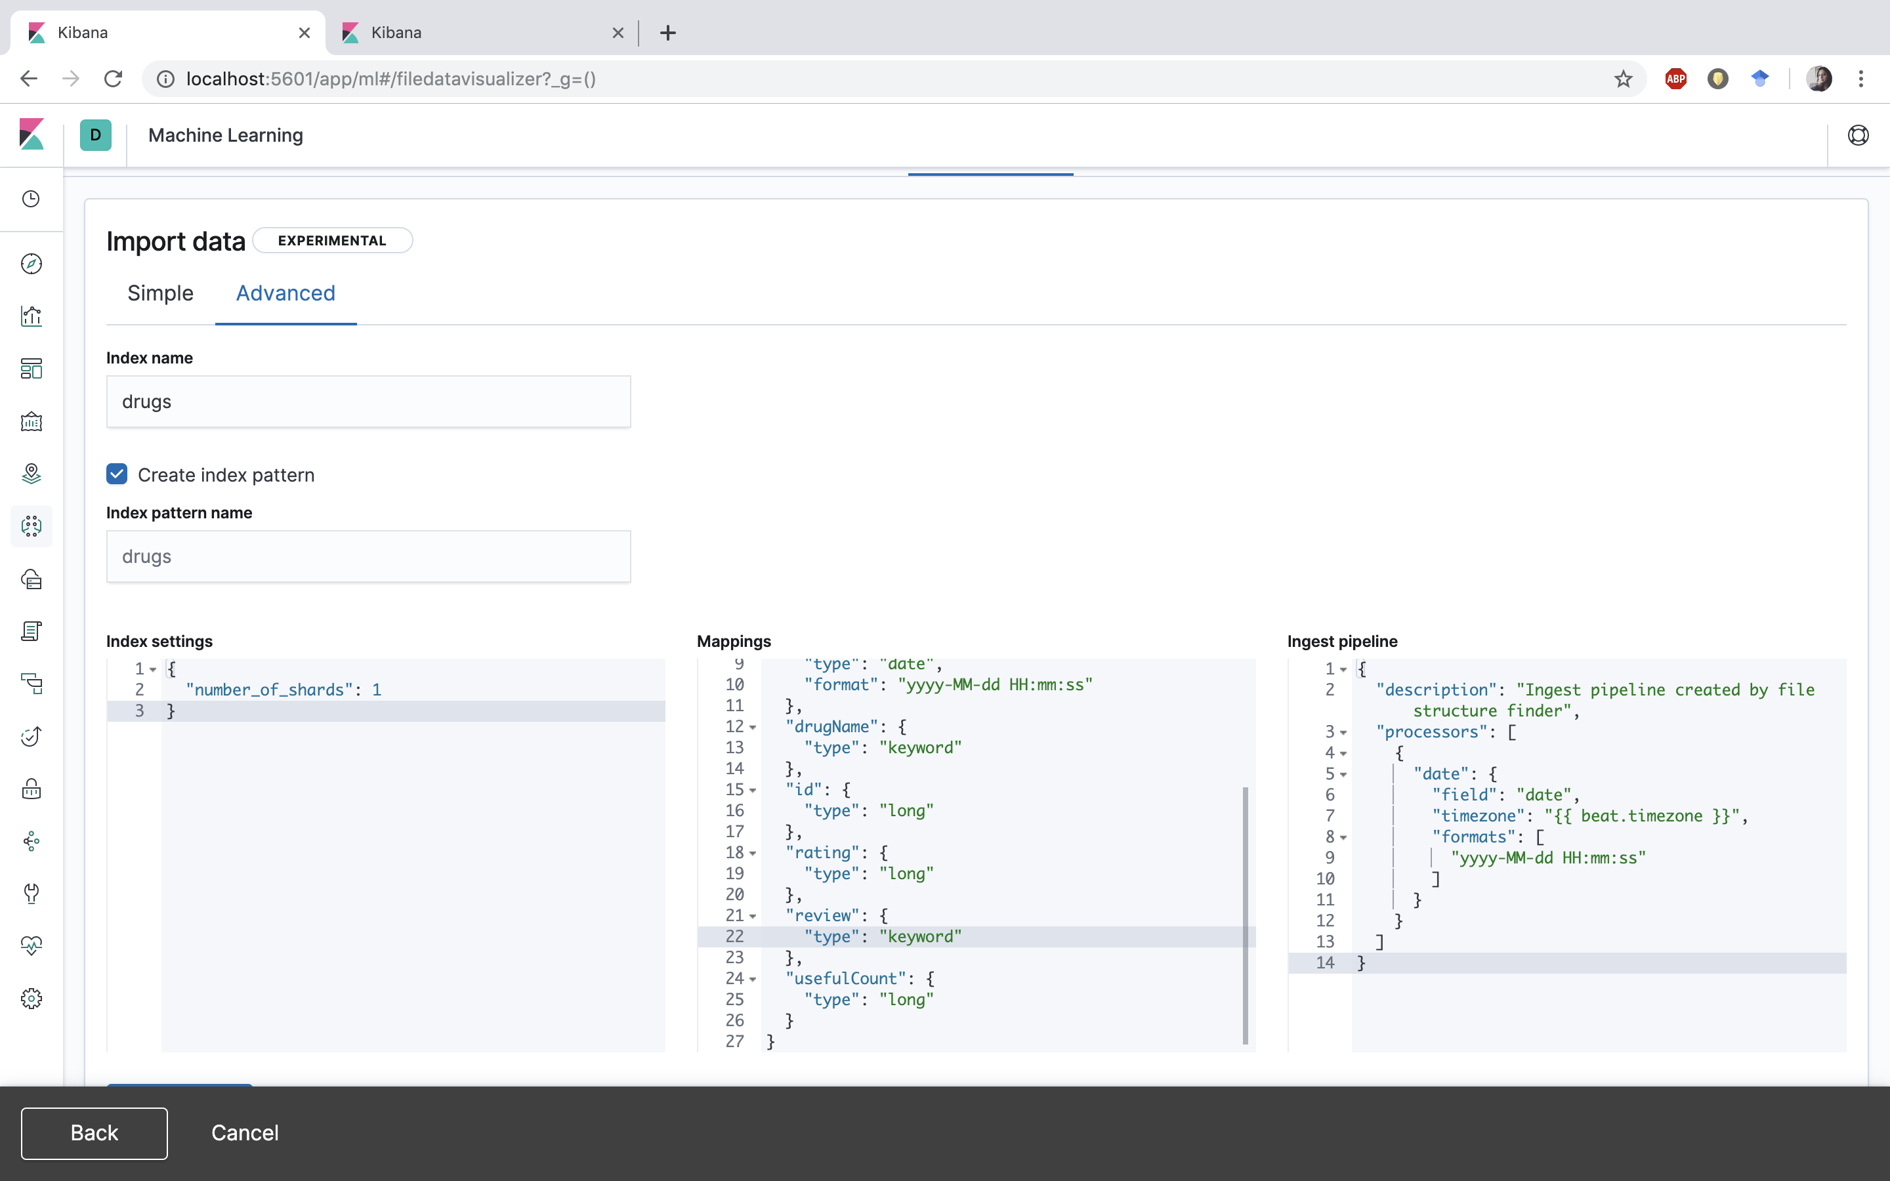

* 1. Click on **Import.** This will create the **index** and **index pattern** with the name as **drugs.**

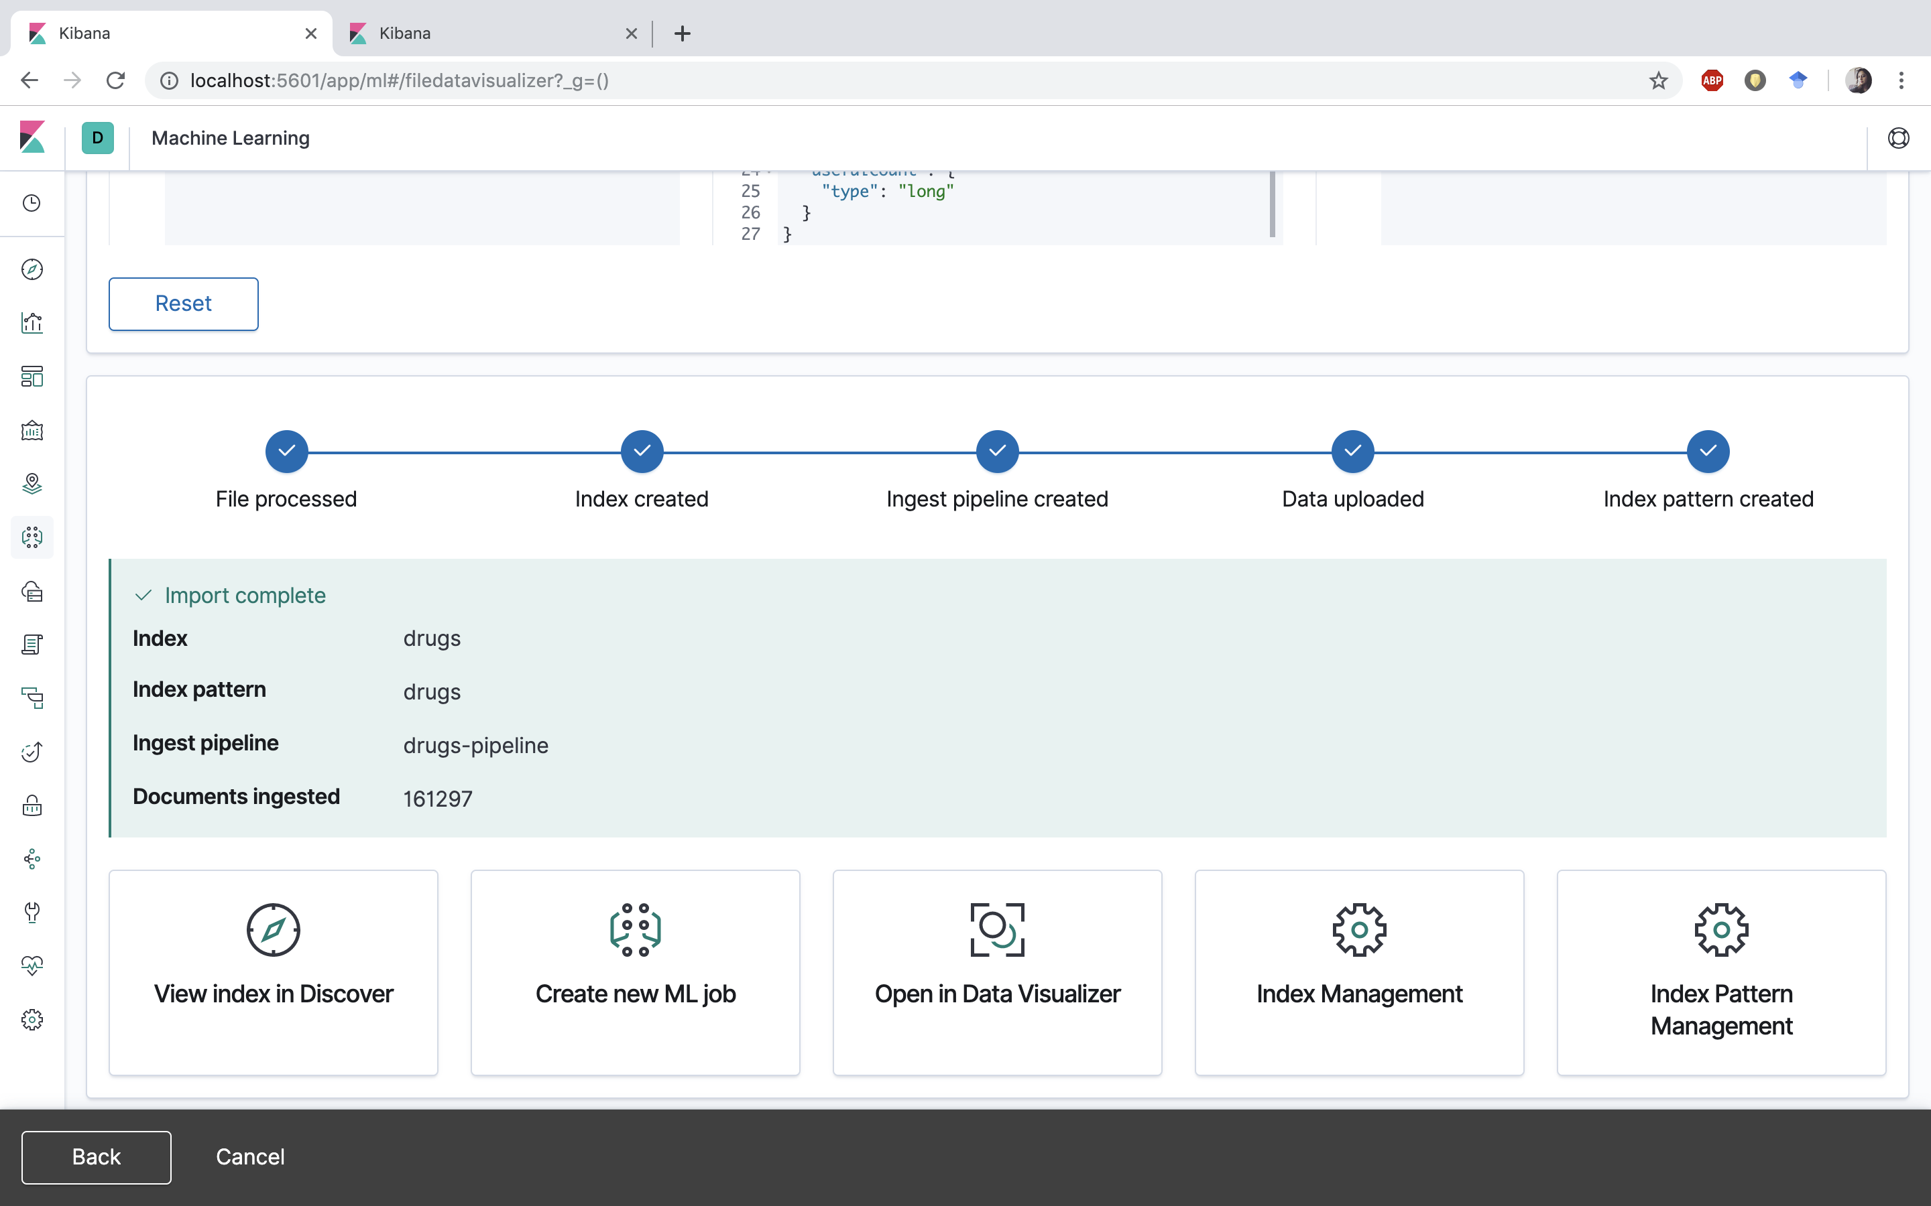

**Visualizing the Data using Kibana**

In the Visualize and Canvas application, you can shape your data using a variety of charts, tables, and maps, and more.

1. In Kibana page, open Visualize and Click **Create new visualization.**

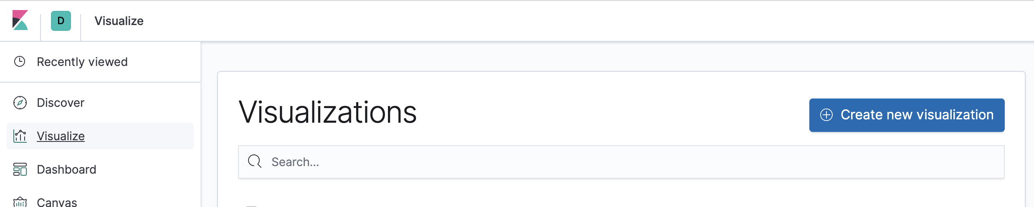

1. Select Pie as visualization type.

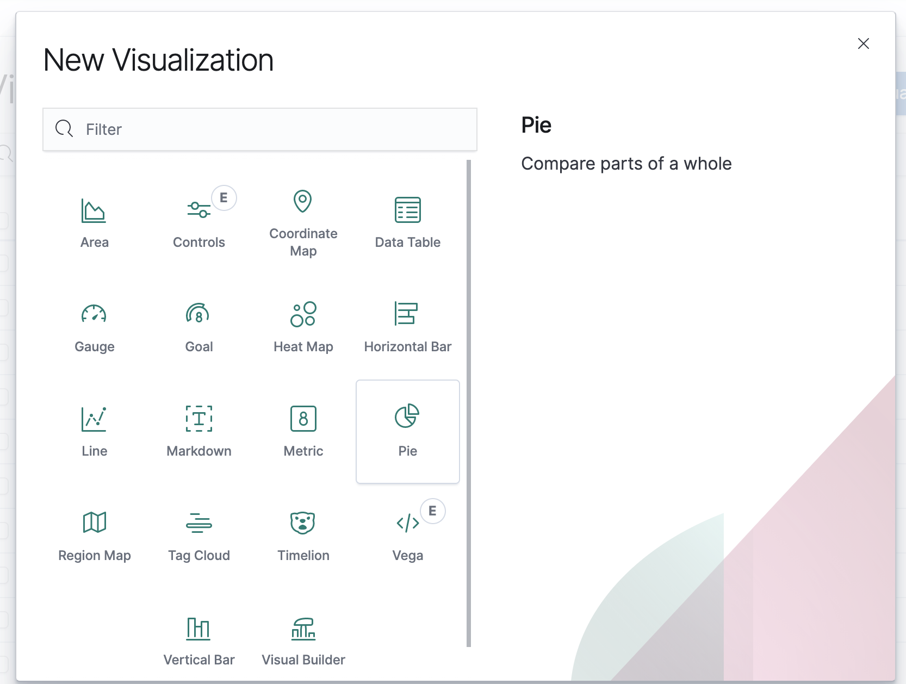

1. Choose the source as drugs.

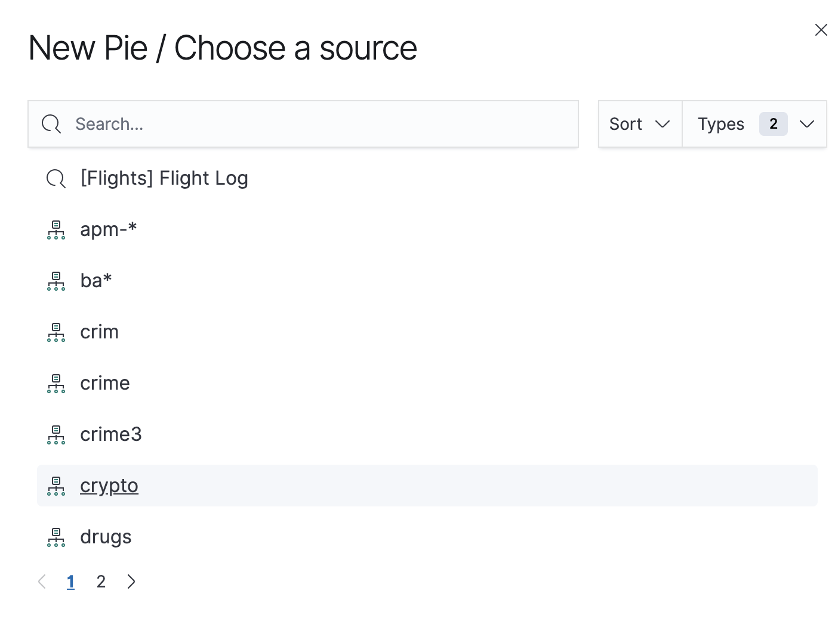

1. In the upper right corner set the starting date as Jan1, 2008 and end date as Dec 31, 2017.

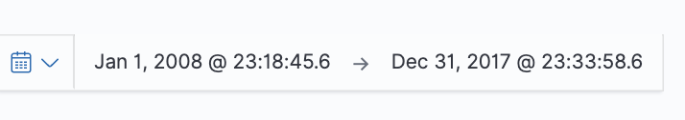

1. In the Data tab, insert the values as shown in the figure below:

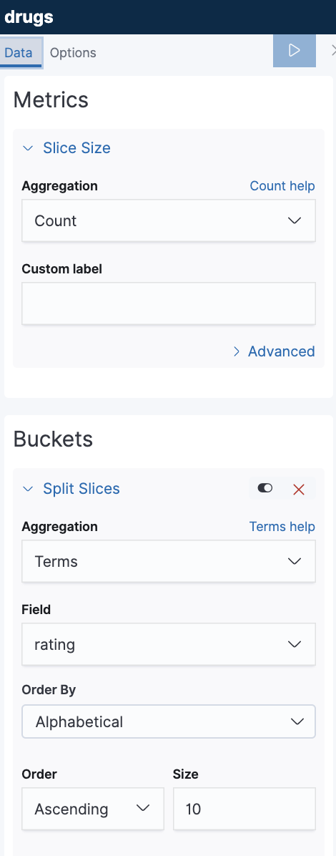

1. Check the box Show Labels under Label Settings in Options tab and apply the changes. The graph shown is the rating distribution. Save the visualization as **Rating Distribution**.

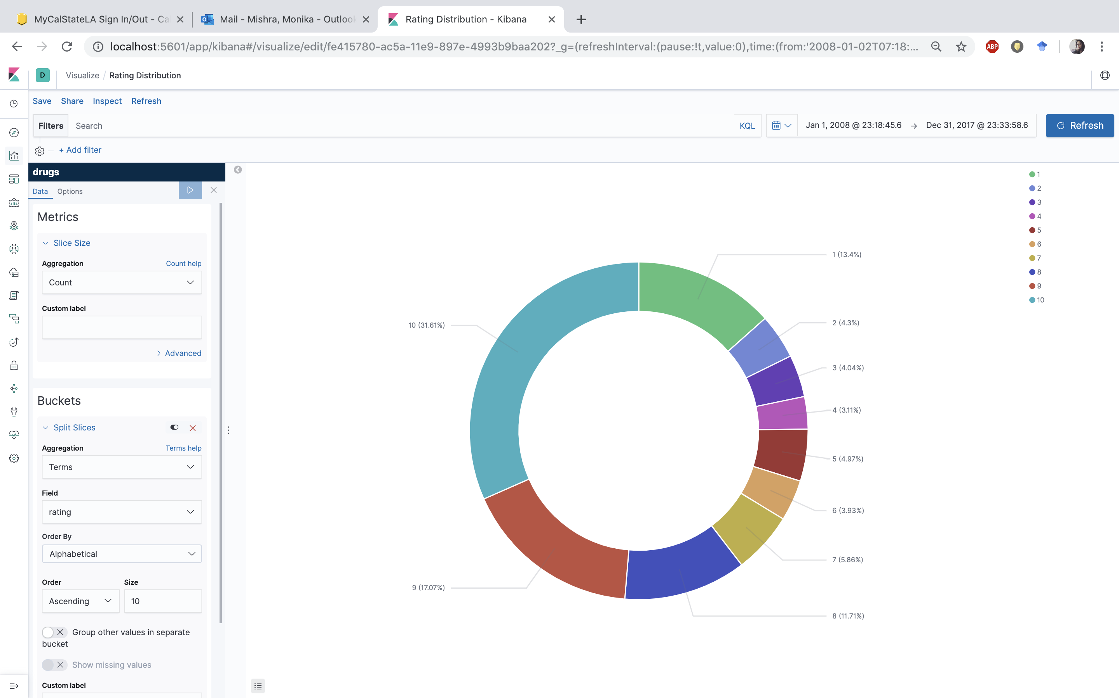

1. Click on **Visualize** -> **Create new visualizations** -> choose visualization type as **Line** -> choose source as **drugs**.
2. In the upper right corner set the starting date as Jan1, 2008 and end date as Dec 31, 2017. Select the values as per given below:

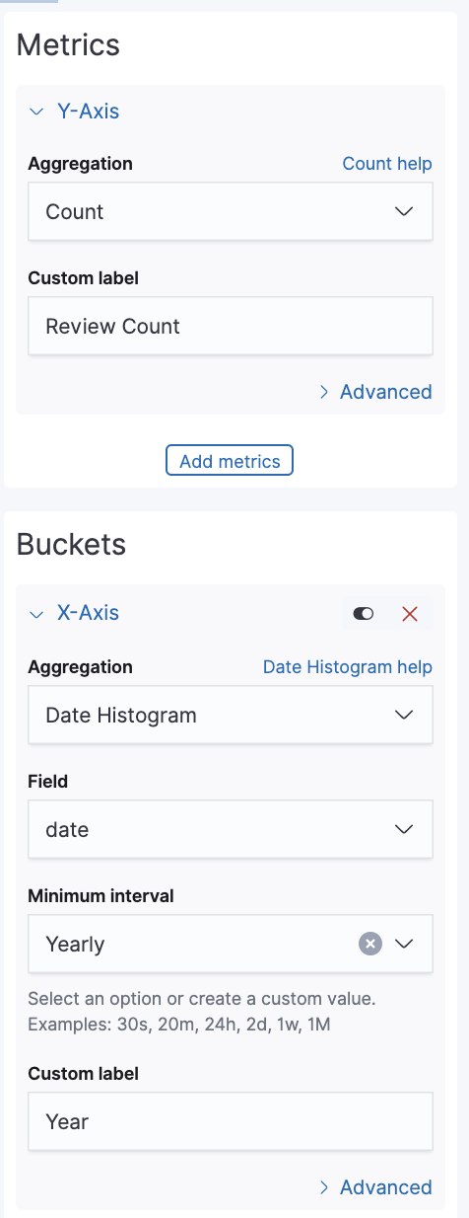

1. The visualization shows the yearly review count trend. Save it as **Review Count by Year**.

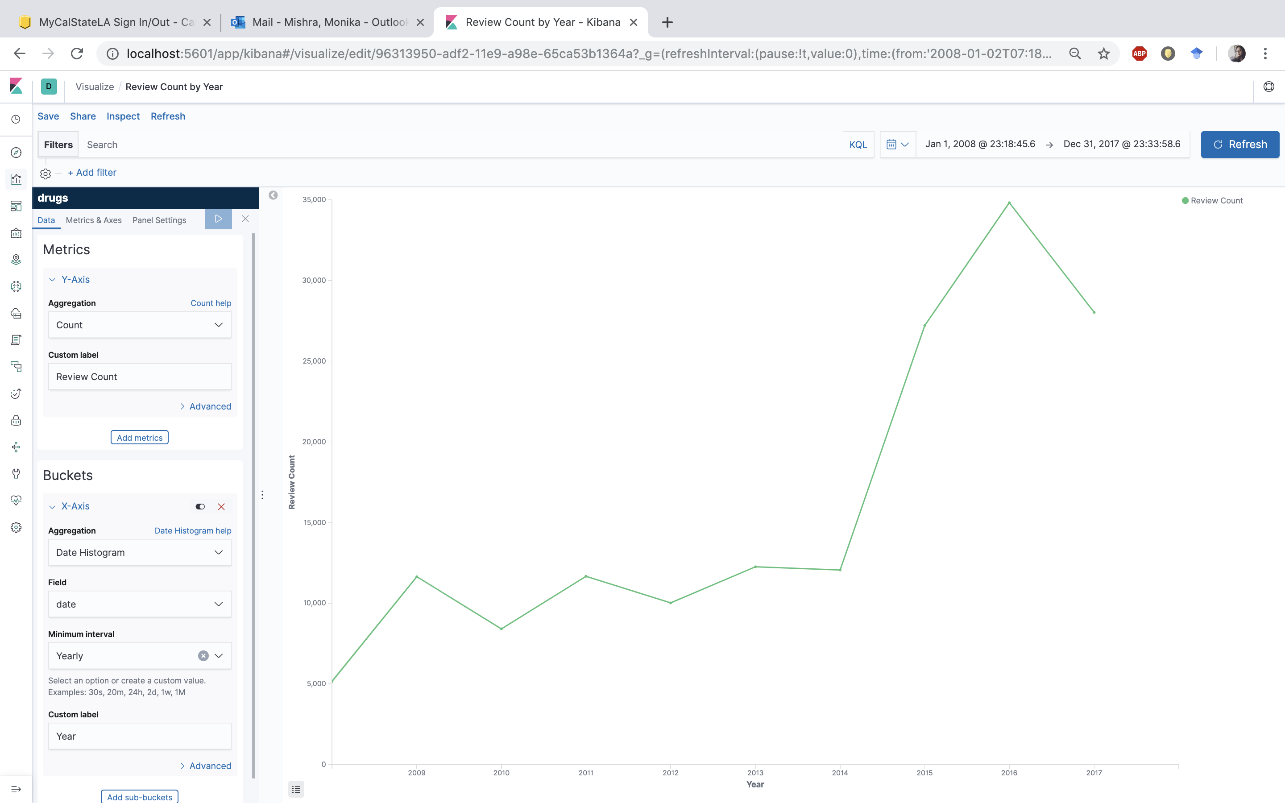

1. Click on **Visualize** -> **Create new visualizations** -> choose visualization type as **Tag Cloud** -> choose source as **drugs**.
2. In the upper right corner set the starting date as Jan1, 2008 and end date as Dec 31, 2017. Select the values as per given below and apply changes:

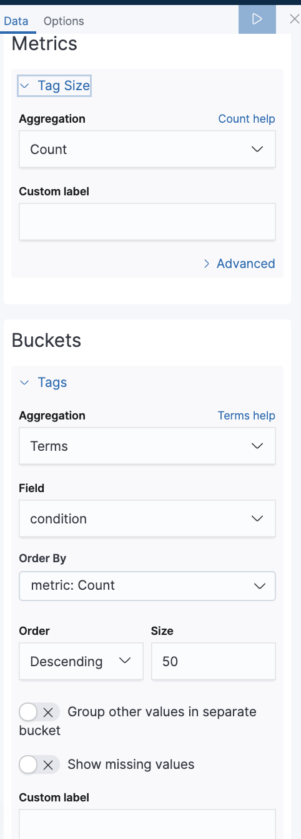

1. The visualization shows the most common medical conditions. Save the visualization as **Condition – Tag 1**

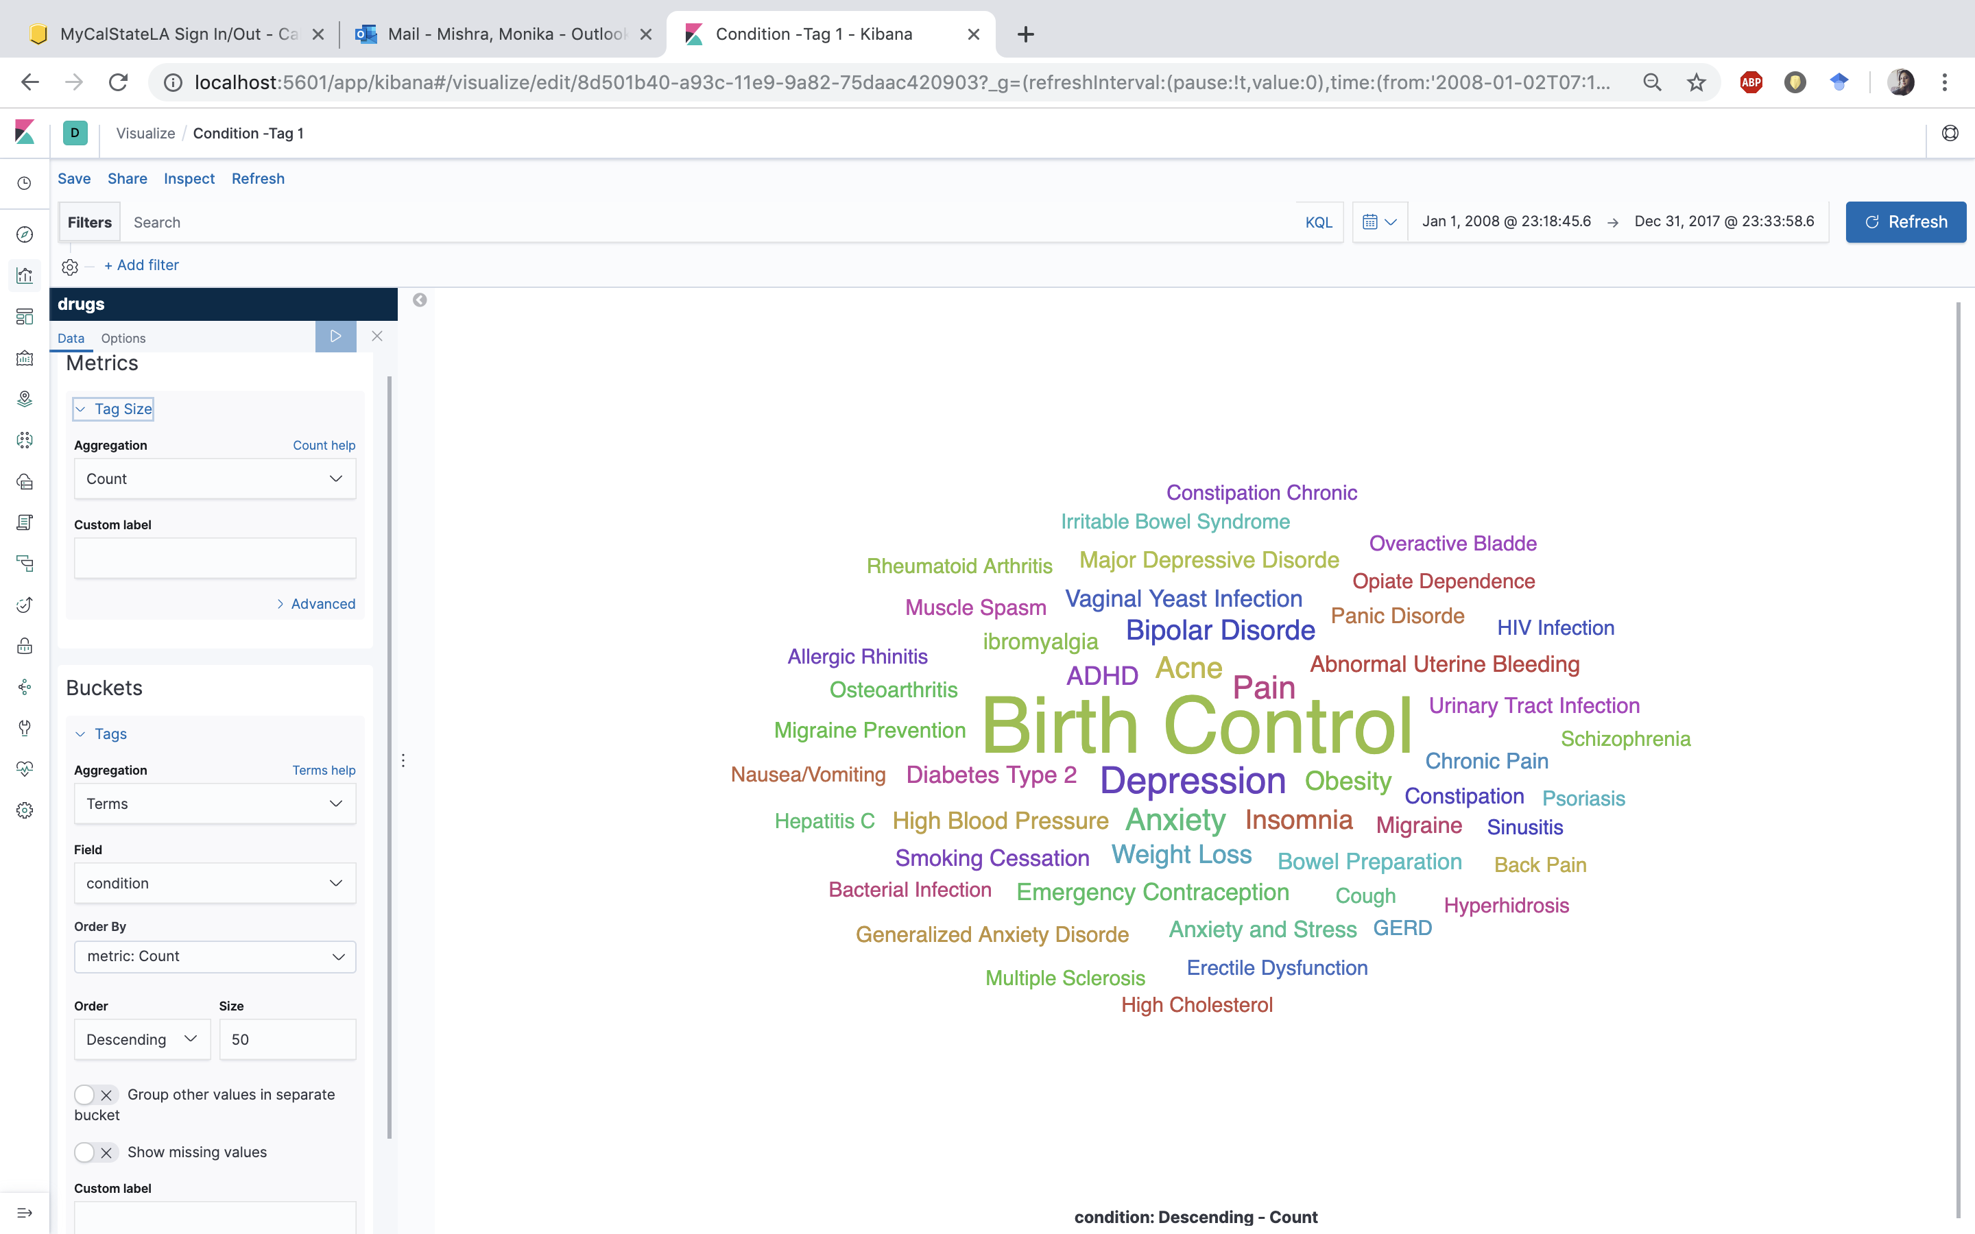

1. Click on **Visualize** -> **Create new visualizations** -> choose visualization type as **Horizontal Bar** -> choose source as **drugs**.
2. In the upper right corner set the starting date as Jan1, 2008 and end date as Dec 31, 2017. Select the values as per given below:

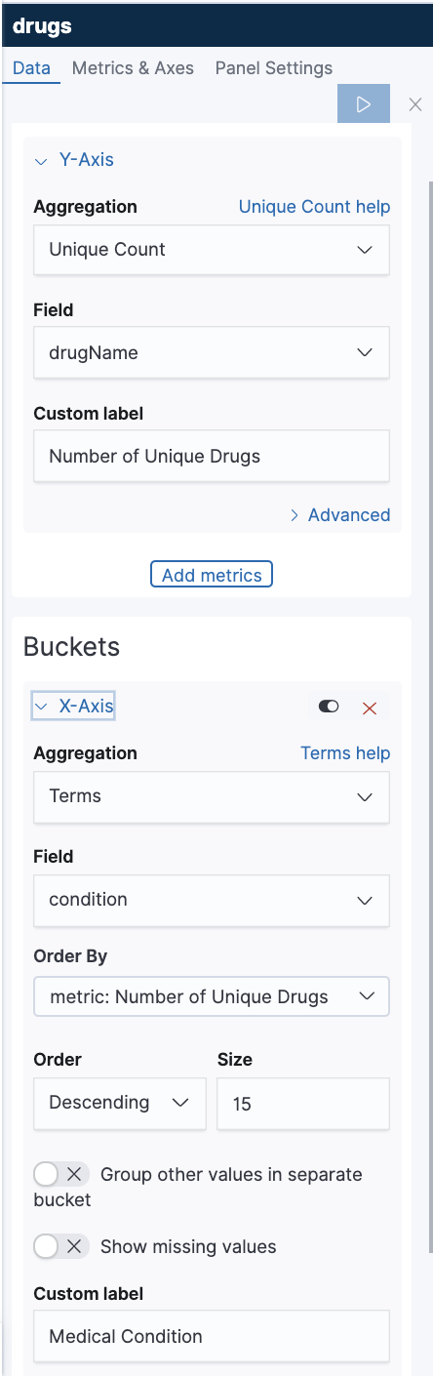

1. The visualization shows the number of drugs per condition. Save it with the name **Drugs per condition**.

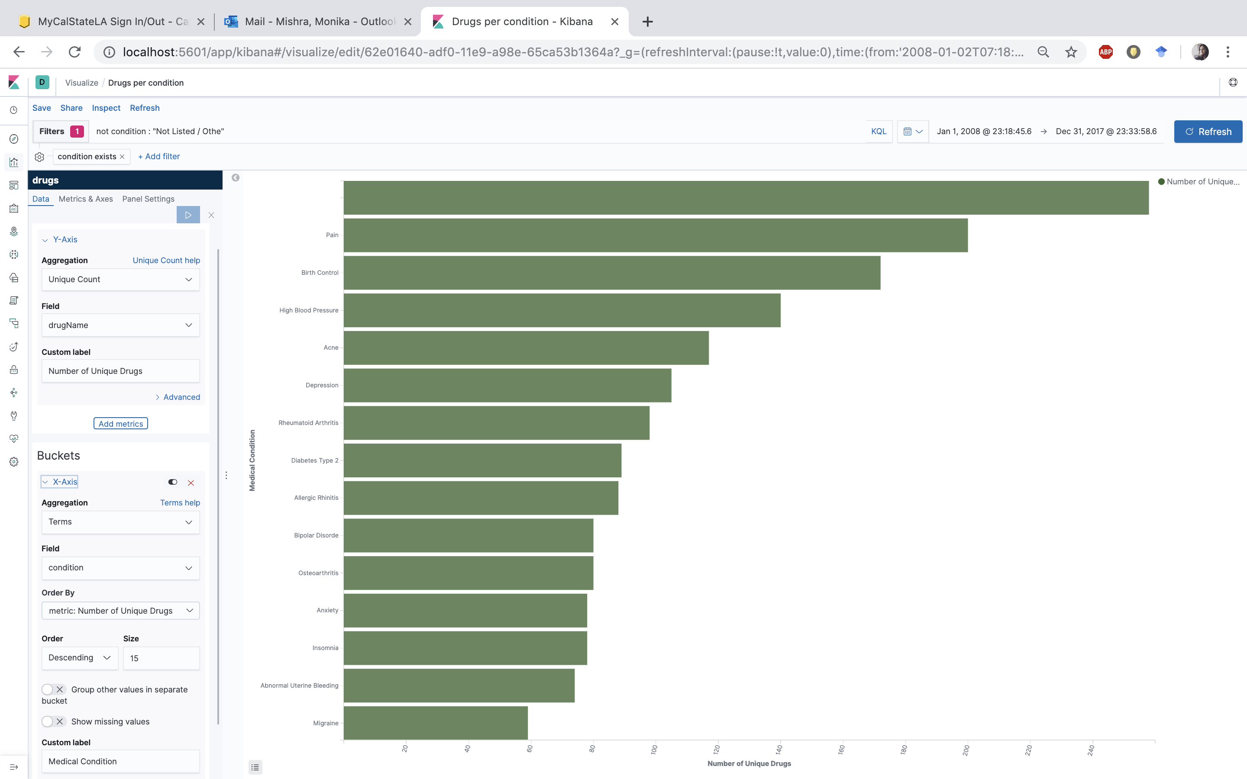

1. Click on **Visualize** -> **Create new visualizations** -> choose visualization type as **Vertical Bar** -> choose source as **drugs**.
2. In the upper right corner set the starting date as Jan1, 2008 and end date as Dec 31, 2017. Select the values as per given below and apply changes:

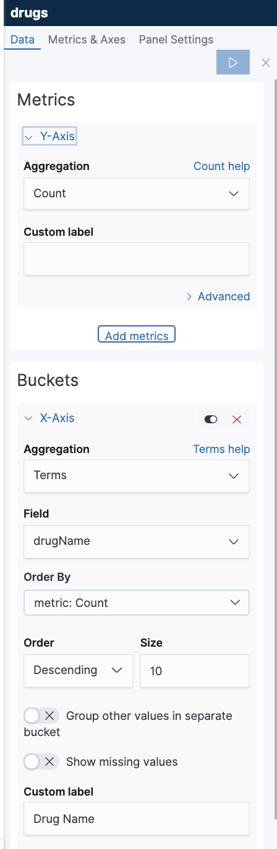

1. The visualization shows the most reviewed drugs. Save it as **Drug Count**.

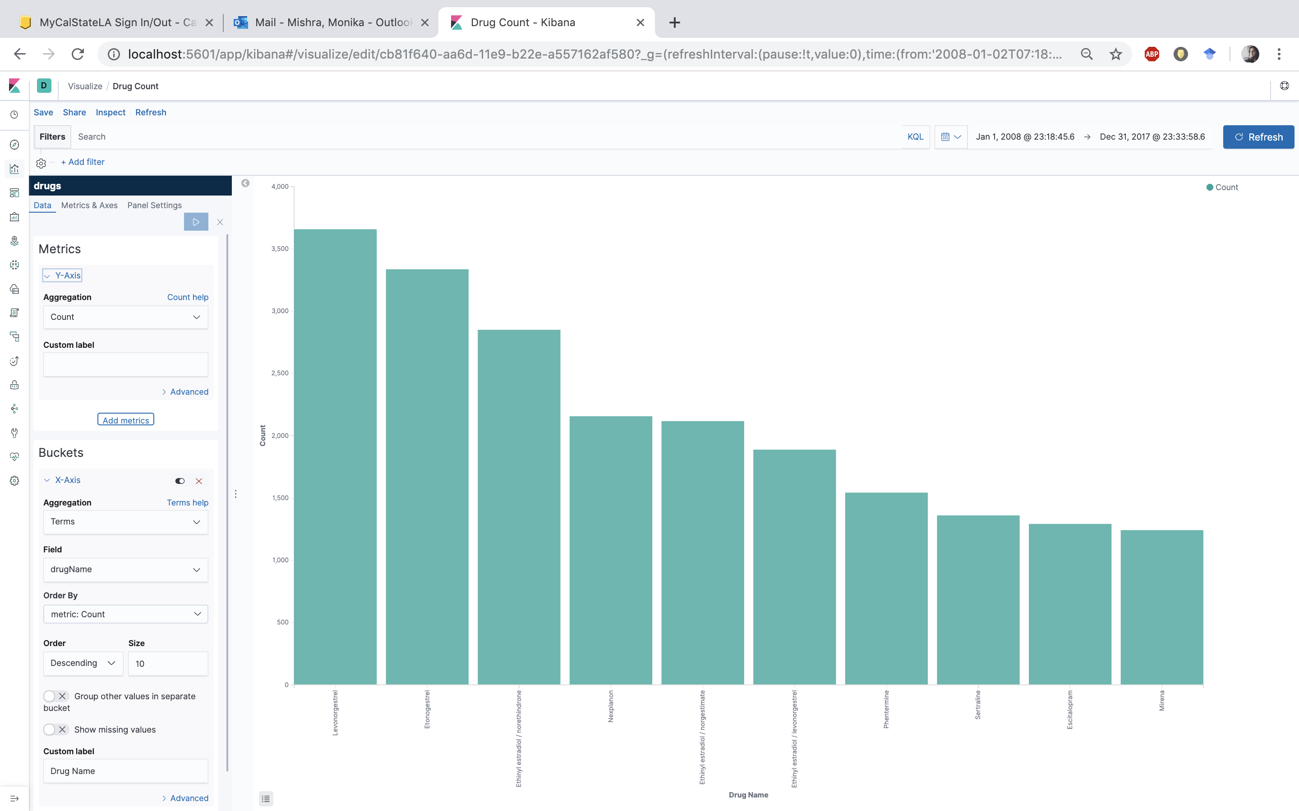

1. Click on **Visualize** -> **Create new visualizations** -> choose visualization type as **Vertical Bar** -> choose source as **drugs**.
2. In the upper right corner set the starting date as Jan1, 2008 and end date as Dec 31, 2017. Select the values as per given below:

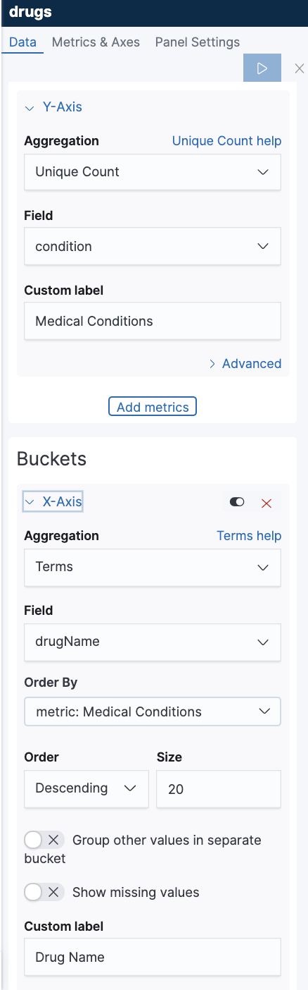

1. The visualization shows the drugs used in multiple medical conditions. Save it as **Drugs-multiple conditions.**

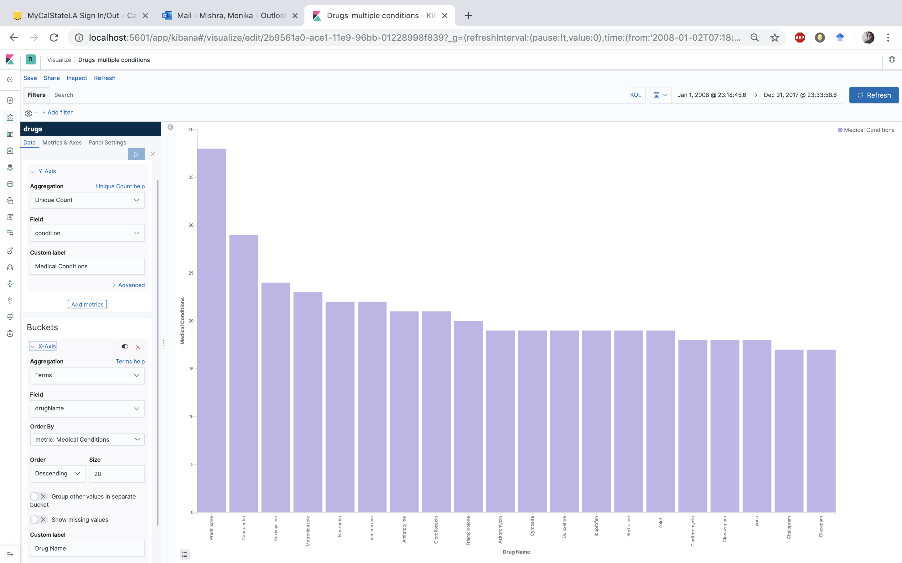

1. Click on **Visualize** -> **Create new visualizations** -> choose visualization type as **Tag Cloud** -> choose source as **drugs**.
2. In the upper right corner set the starting date as Jan1, 2008 and end date as Dec 31, 2017. We want to know in what type of medical conditions is the medicine “Prednisone” is used. In the Filters field add the following - **drugName : "Prednisone"**

Select the values as per given below:

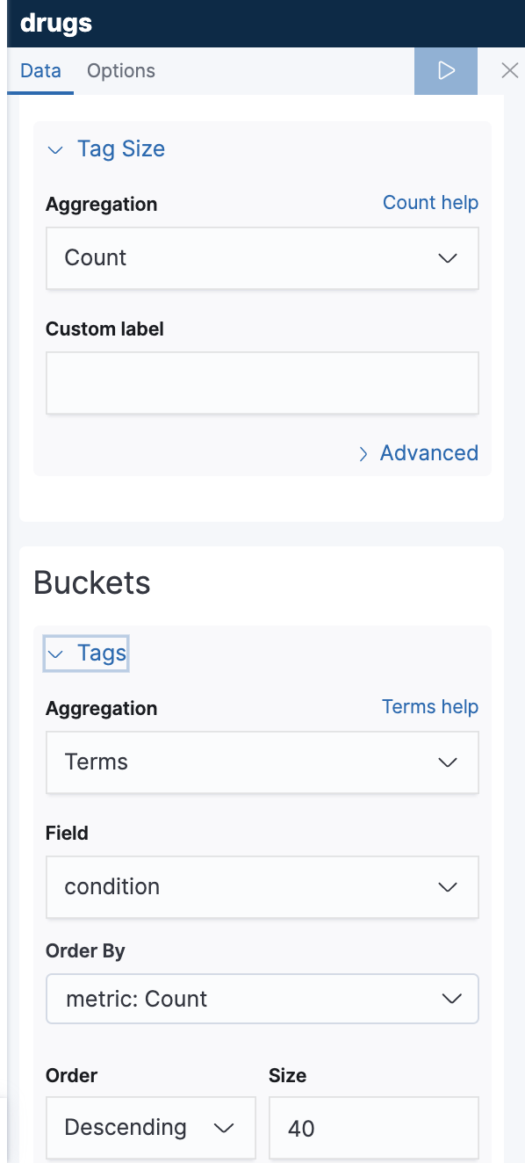

1. The visualization medical conditions cured by Prednisone. Save it as **drugName : “Prednisone”**

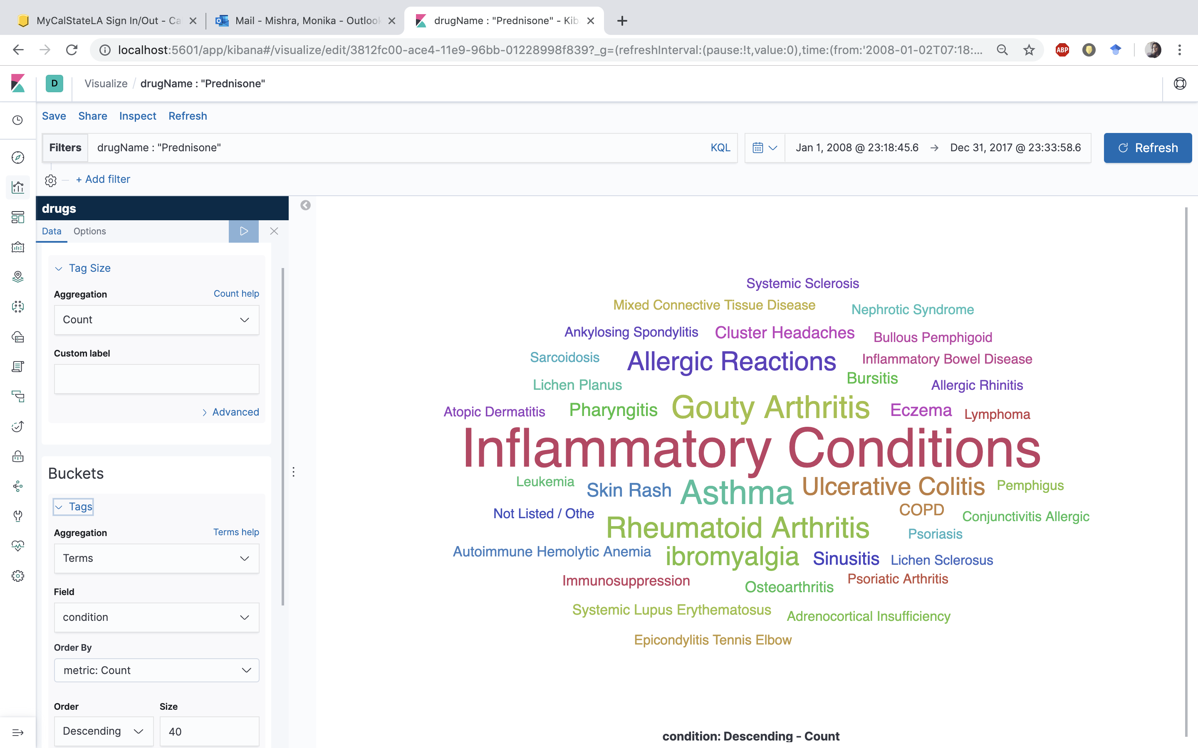

1. Click on **Visualize** -> **Create new visualizations** -> choose visualization type as **Vertical Bar** -> choose source as **drugs**.
2. In the upper right corner set the starting date as Jan1, 2008 and end date as Dec 31, 2017. Select the values as per given below:

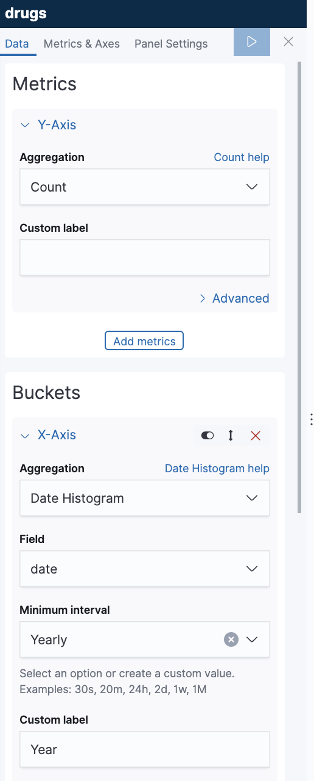

1. Next, we are going to split the series as below:

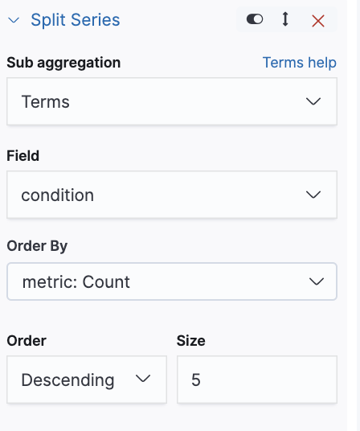

1. The visualization shows the top 5 most reviewed medical conditions each year. Save it as **High Medical Conditions over the years**.

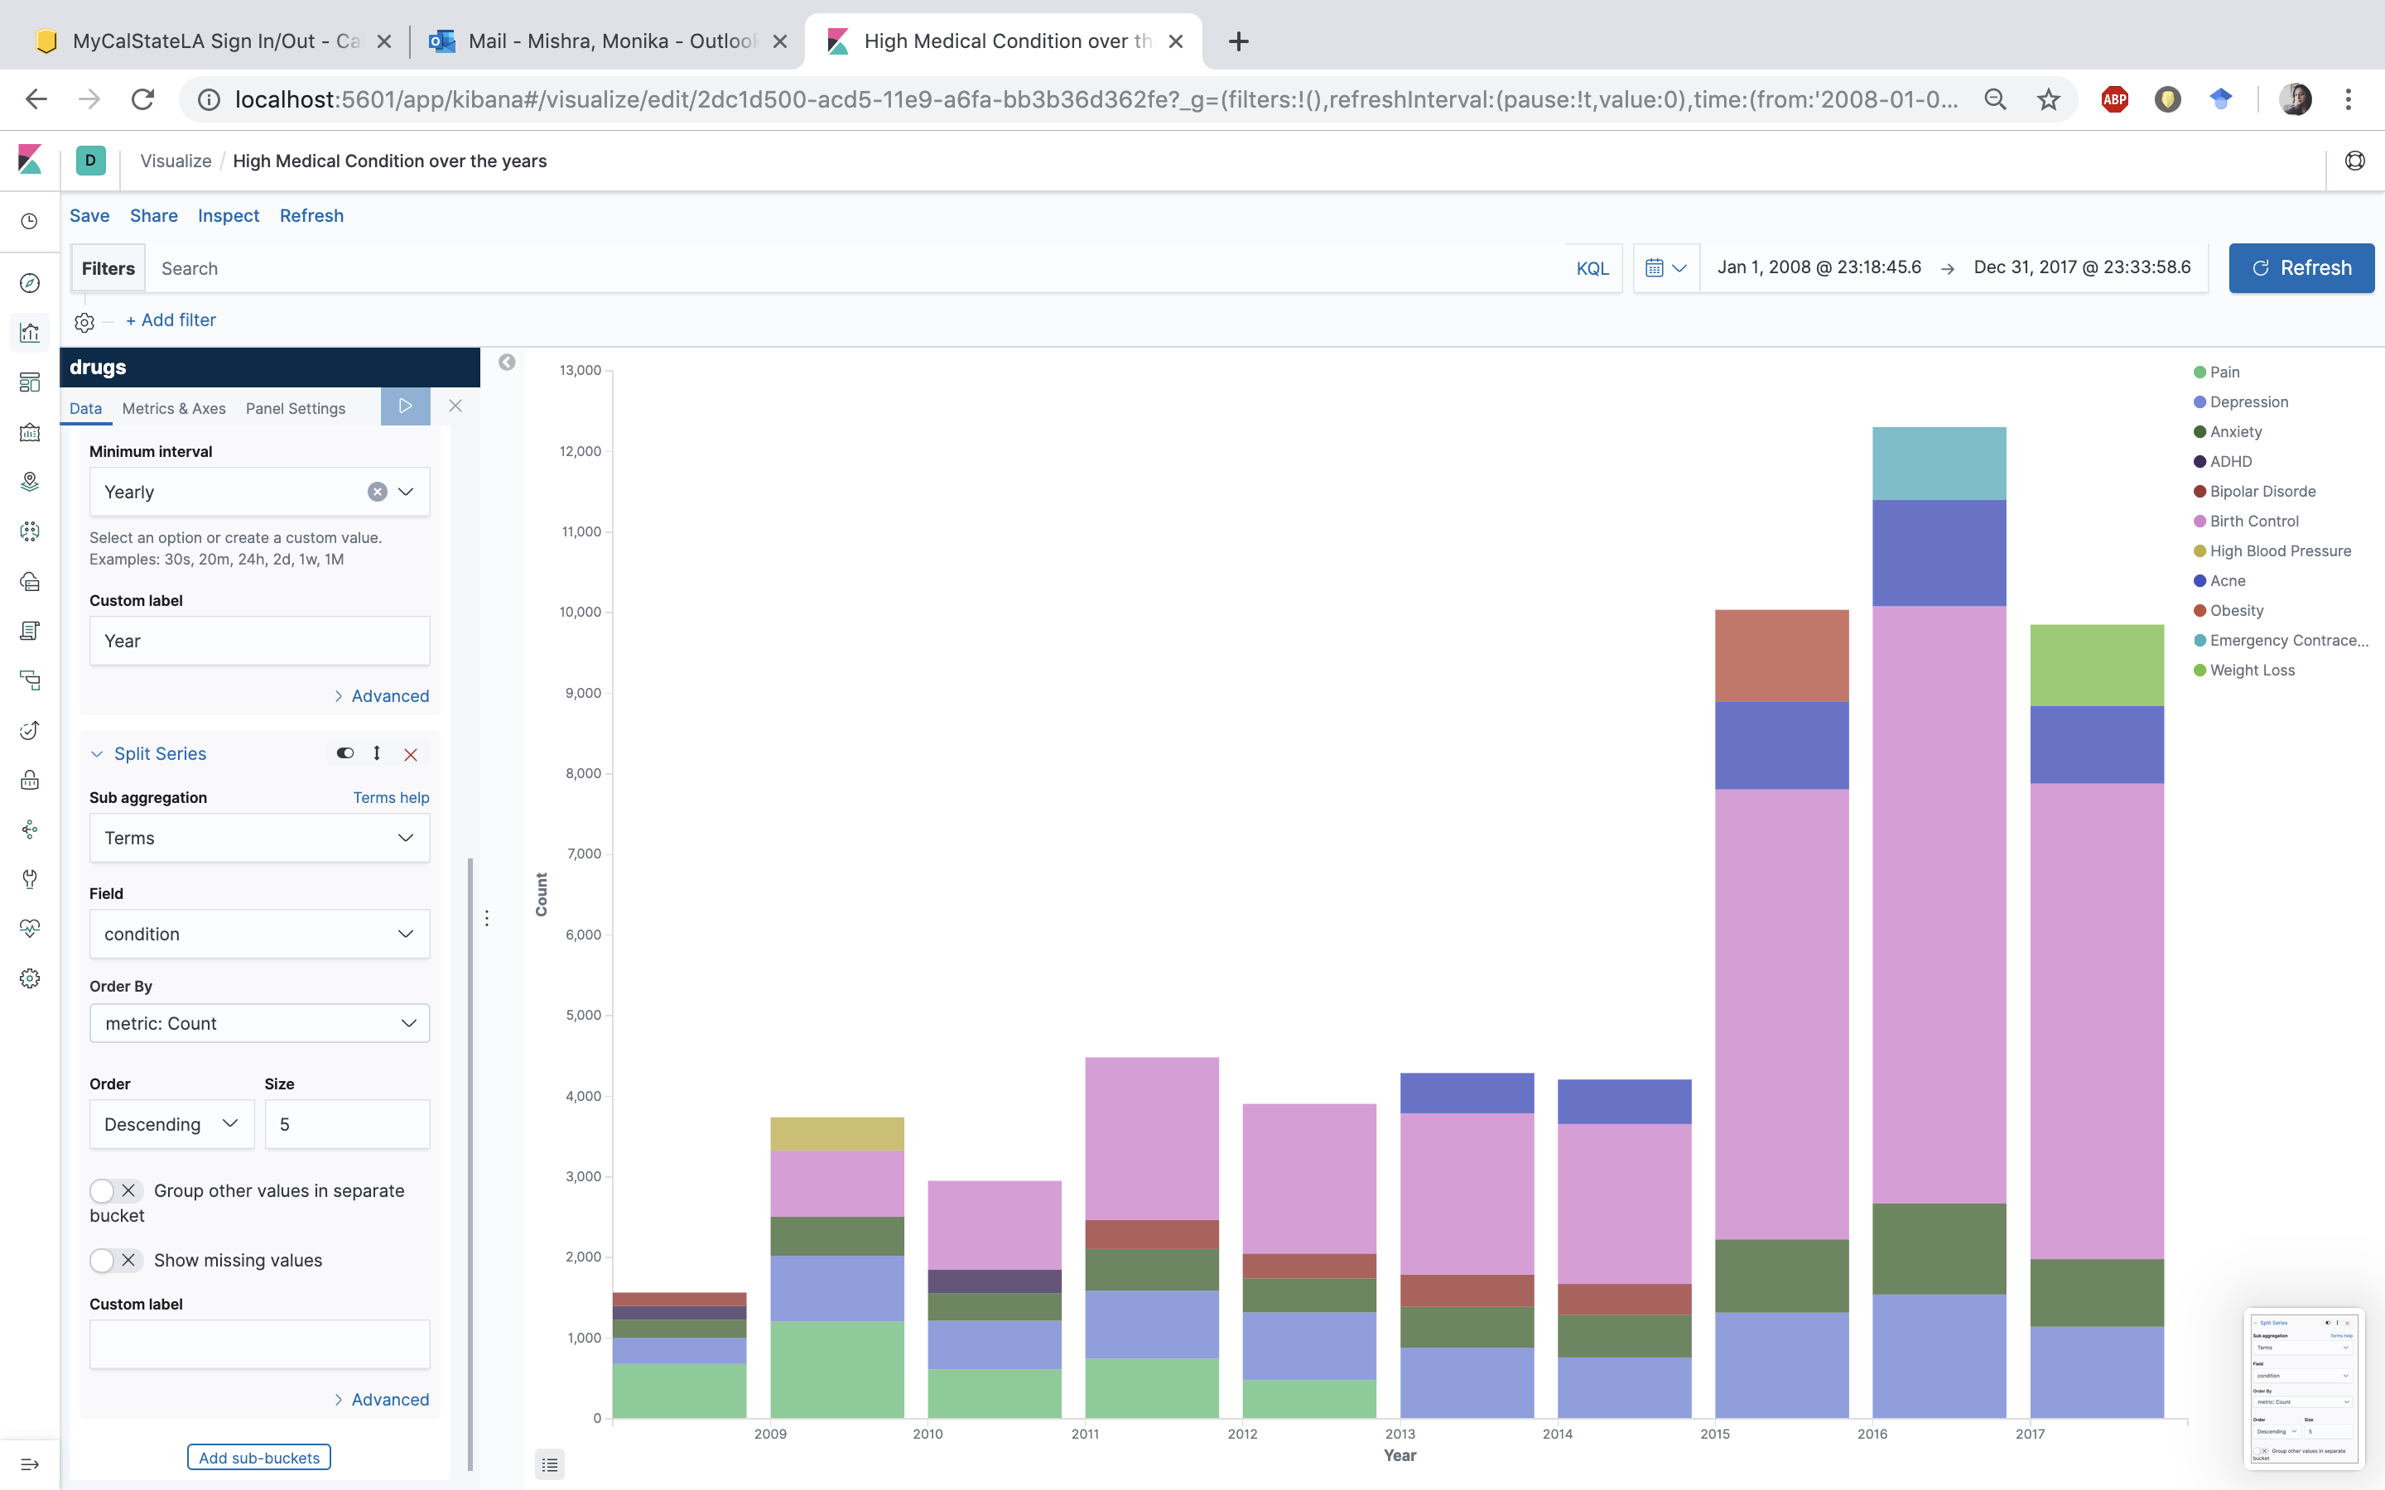

1. Canvas is another Kibana tool which is used for visualization. The Elasticsearch SQL makes it easier to query and create visualization. Click on **Canvas** -> **Create workpad** -> **Add element** -> **Horizontal Bar Chart**

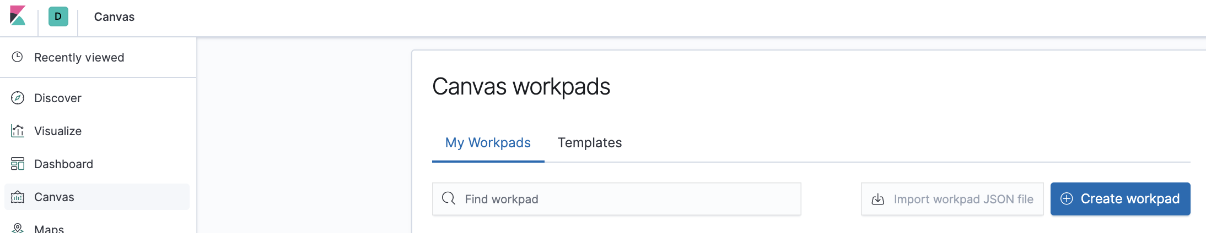

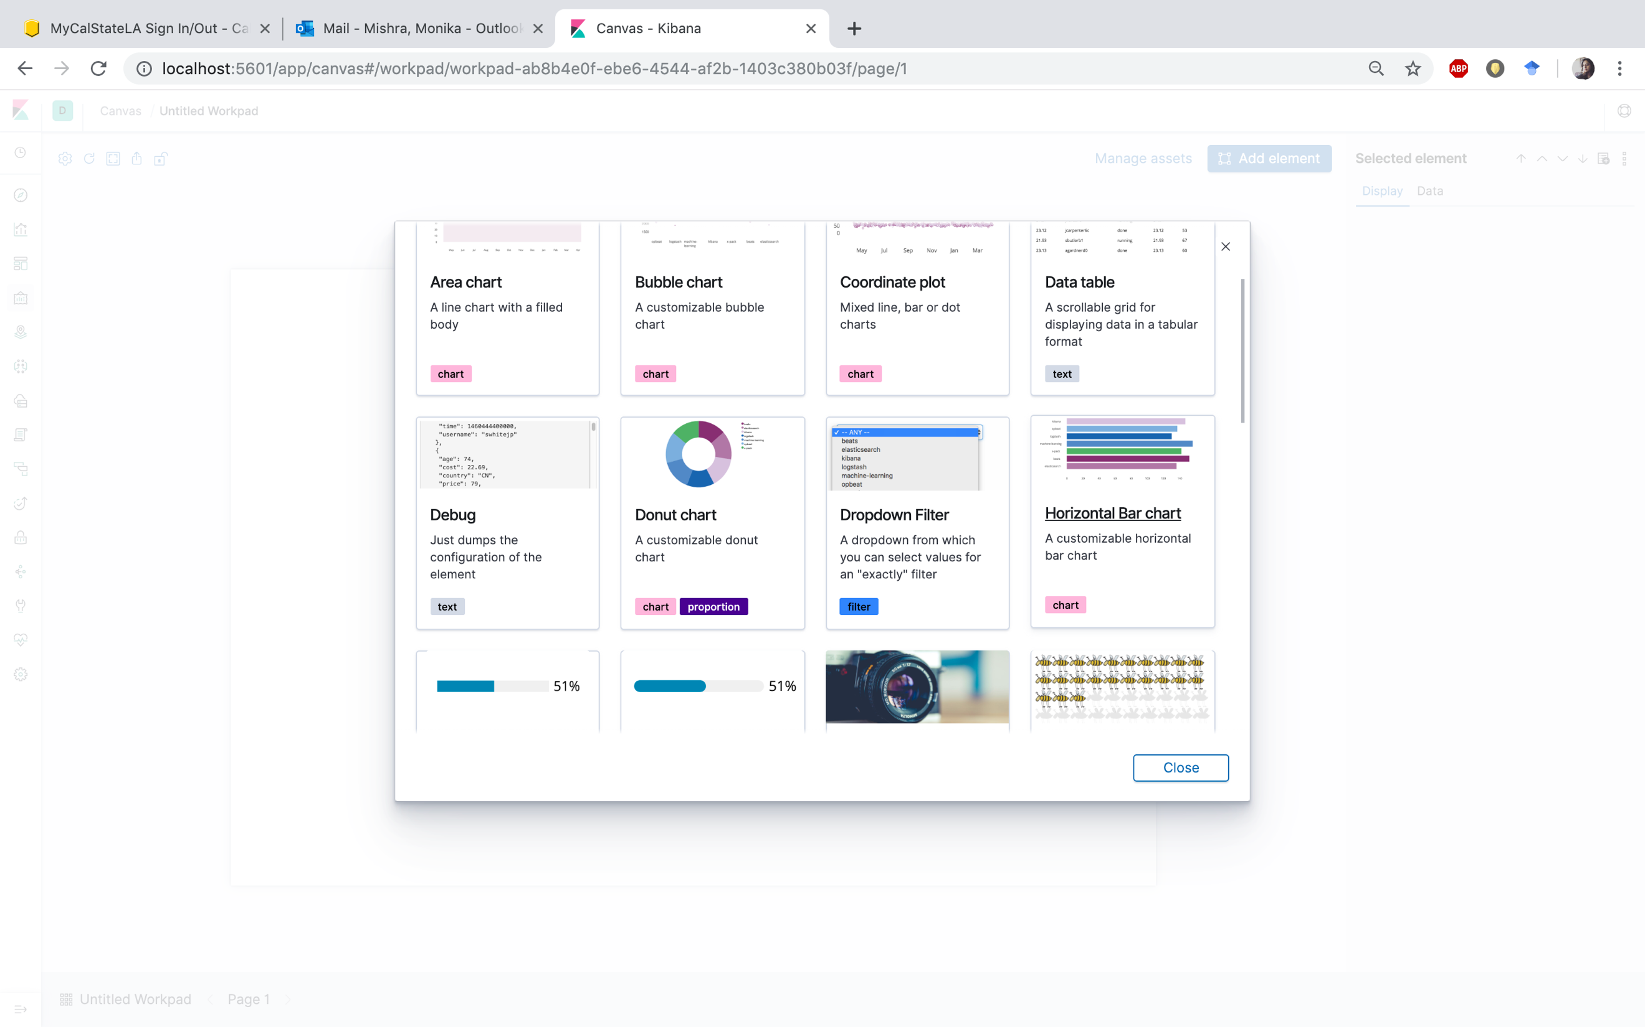

1. Click on **Data** field at the right. Click on **Change your data source**.

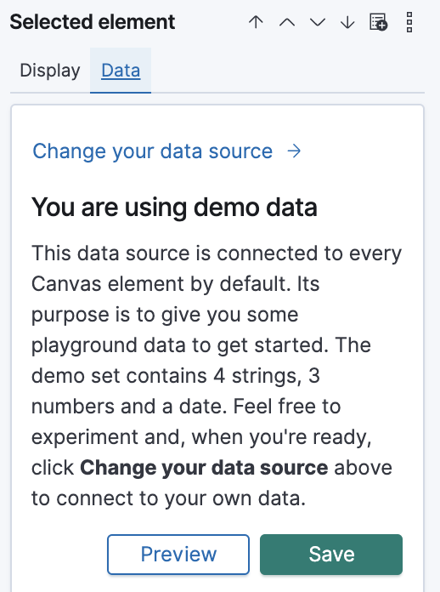

1. Select Elasticsearch SQL

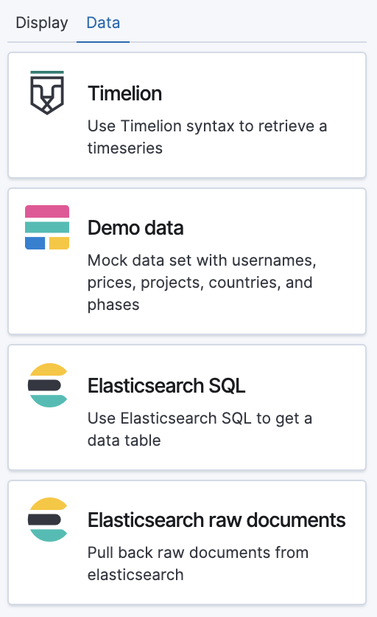

1. In the Elasticsearch SQL query, paste the below SQL script and click Save.

|  |
| --- |
| select avg(rating) "rating" ,  drugName,  count(drugName) "cnt"  from drugs  group by drugName  having cnt >30  order by rating desc  limit 20 |

1. In the **Display** field, populate the values as shown below:

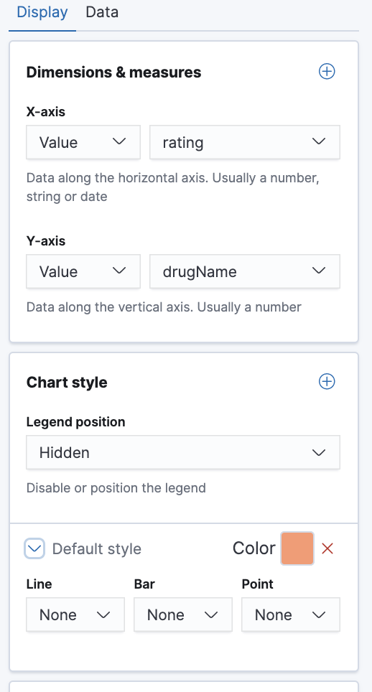

1. The visualization displayed is the top significant drugs with the best average rating having a review count greater than 30. Save it as **significant drugs**.

There are drugs which has been rated 10 but have been reviewed only once or twice. We didn’t want those drugs to come under the best rated drugs. So, we added the condition to consider only those drugs having a review count greater than 30.

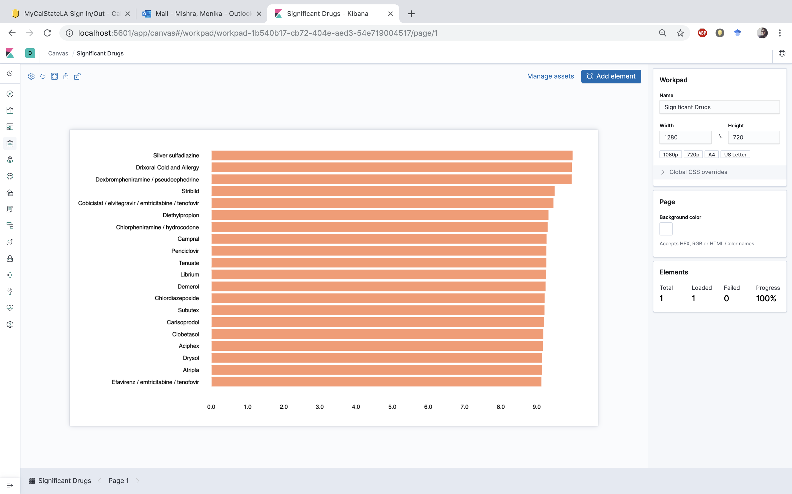

1. Repeat the steps from 29 -33 as above to get the worst rated medicine. Just change the SQL query at step 32 as given below:

|  |
| --- |
| select avg(rating) "rating" ,  drugName,  count(drugName) "cnt"  from drugs  group by drugName  having cnt >30  order by rating asc  limit 20 |

1. The visualization displayed is the significant drugs with the worst average rating having a review count greater than 30. Save it as **insignificant drugs**.

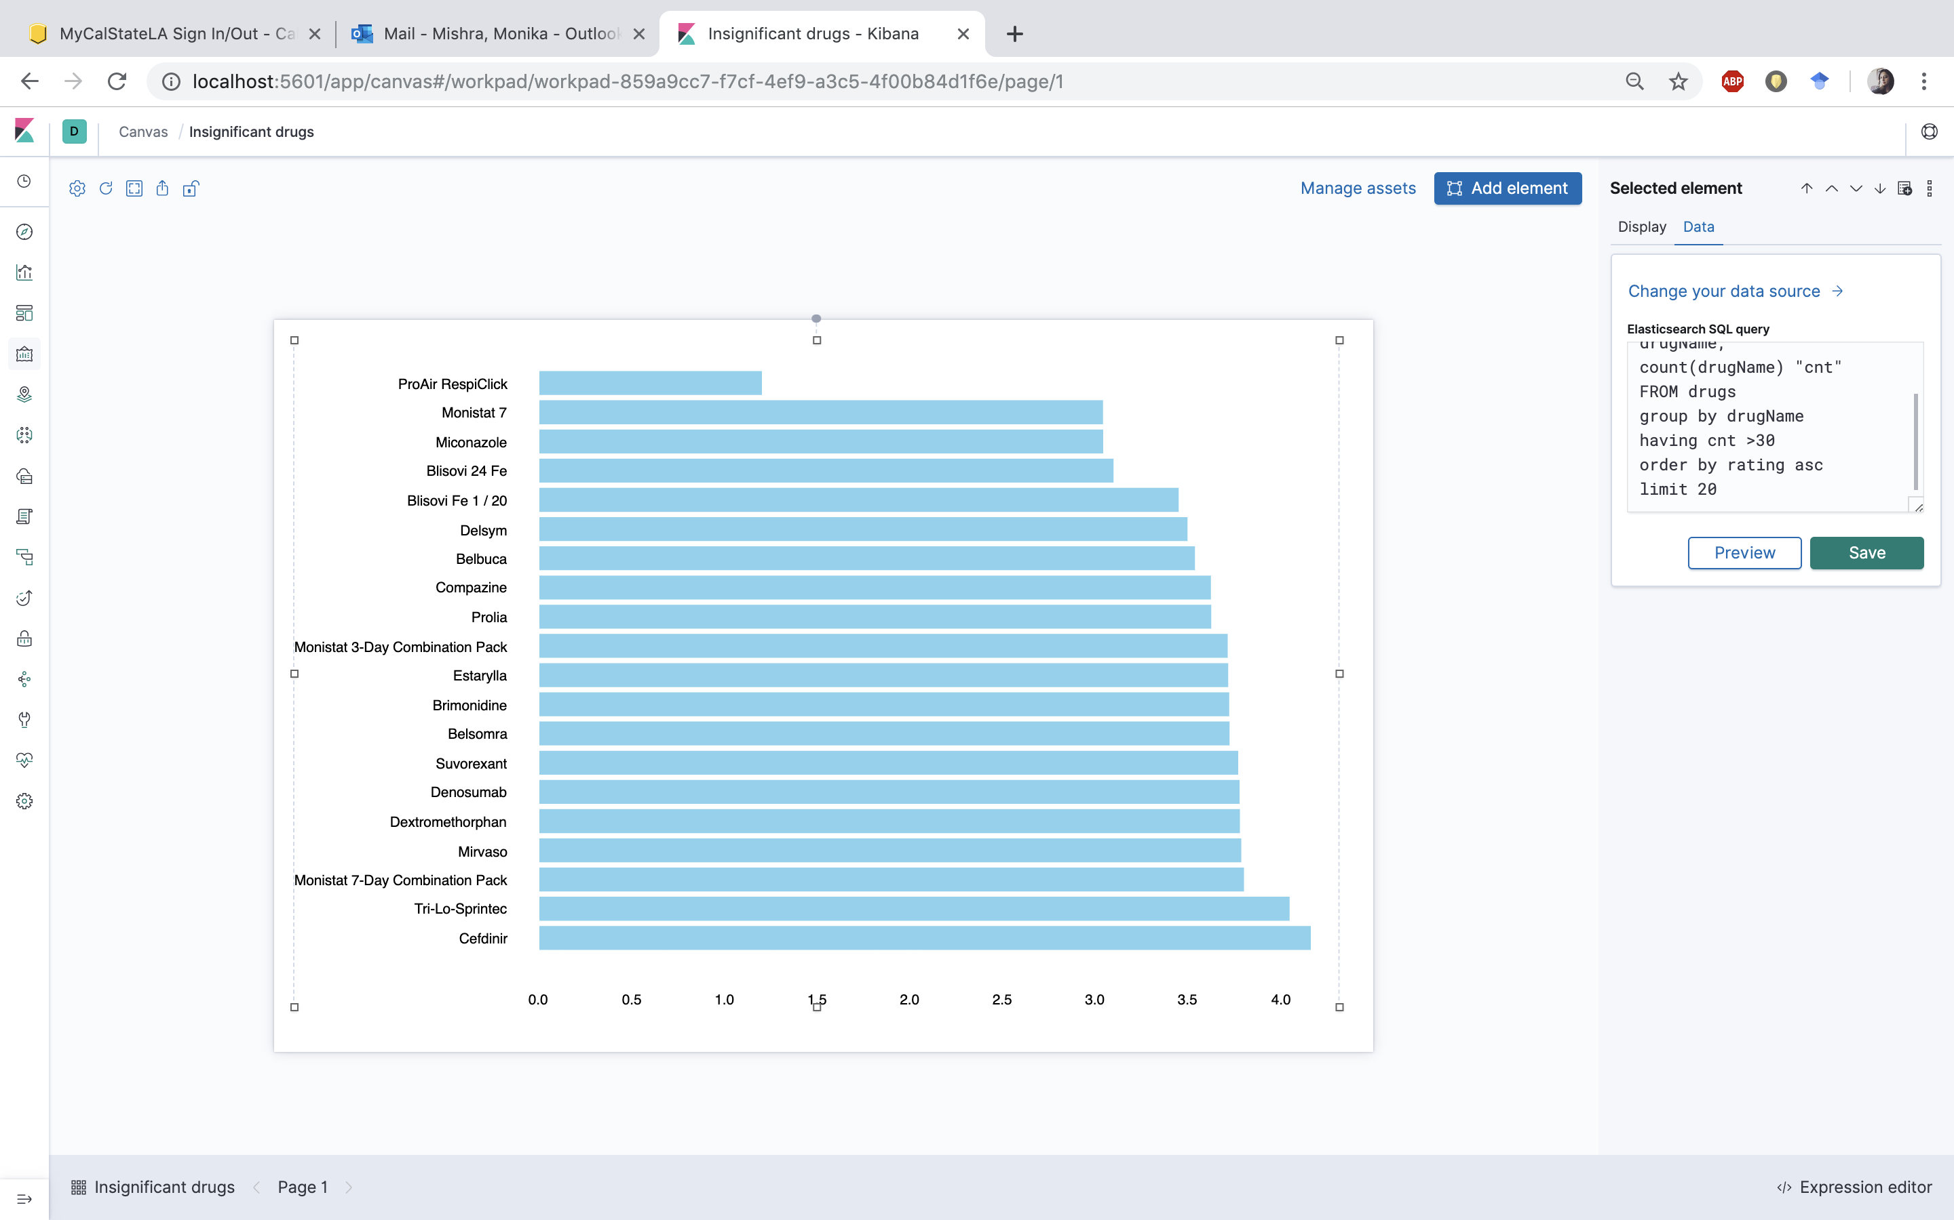

**Anomaly Detection and Forecasting**

Machine Learning makes it easy to detect anomalies in time series data stored in Elasticsearch. An anomaly can be defined as an observed behavior which appears different to the expected or specified behavior. An anomaly is always caused by an error or a defect. IN the drugs dataset, we are implementing Machine Learning technique to find anomaly in the average rating of the drugs.

1. Open the Machine Learning tab present in Kibana and click on **Create new job** on the right side.

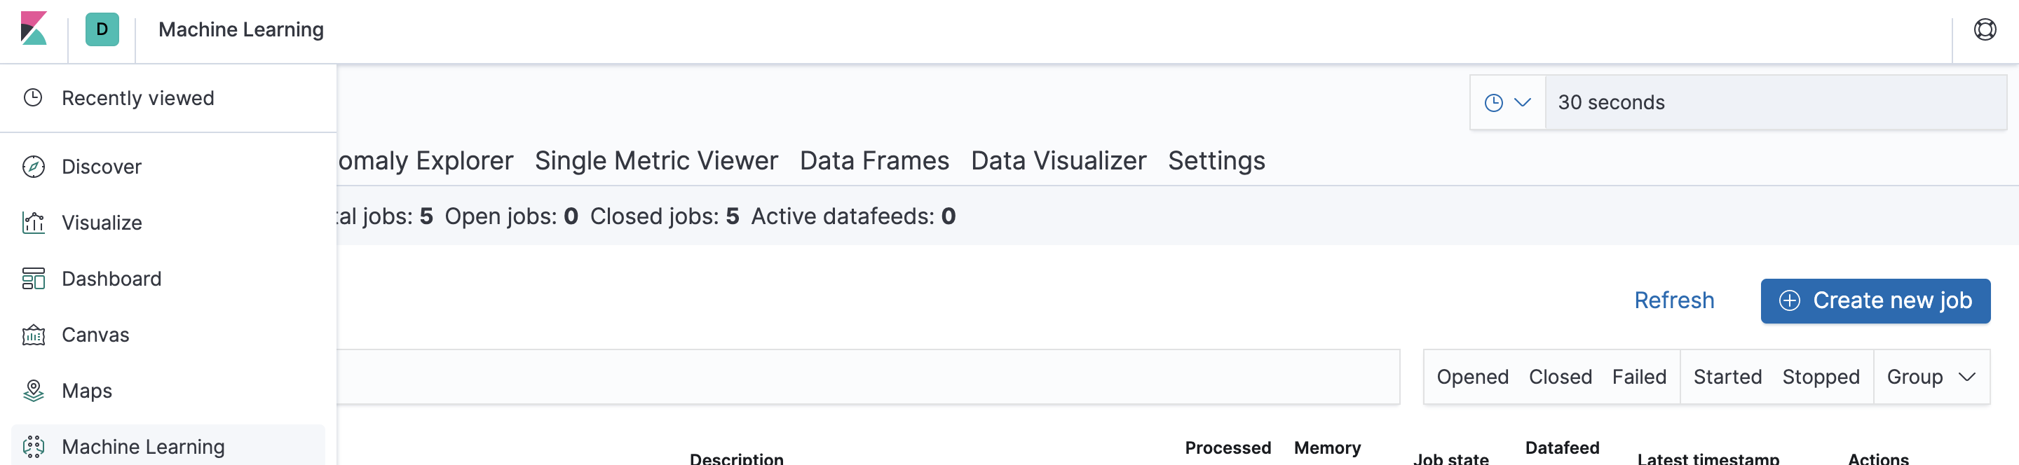

1. Select the index drugs.

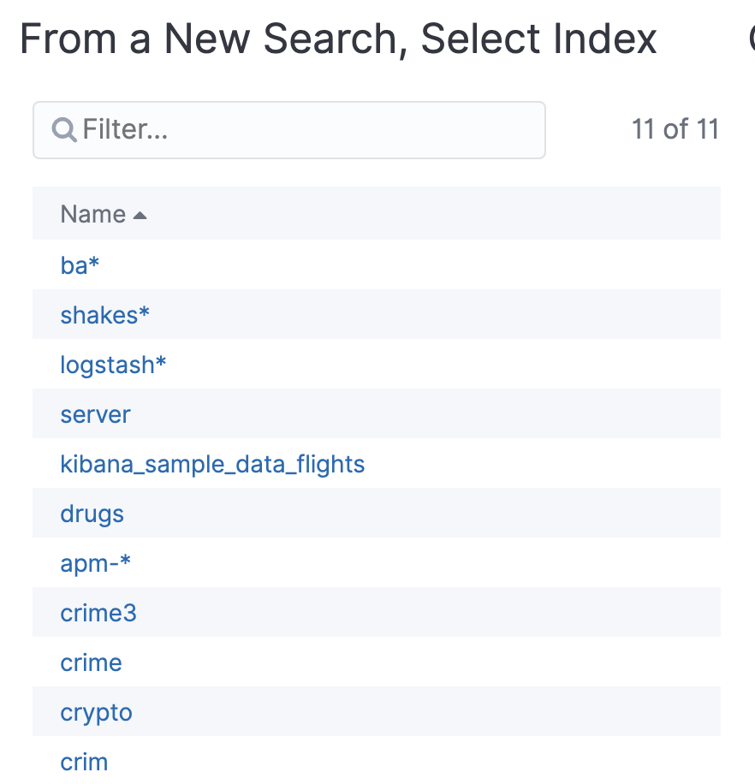

1. Click on Single metric.

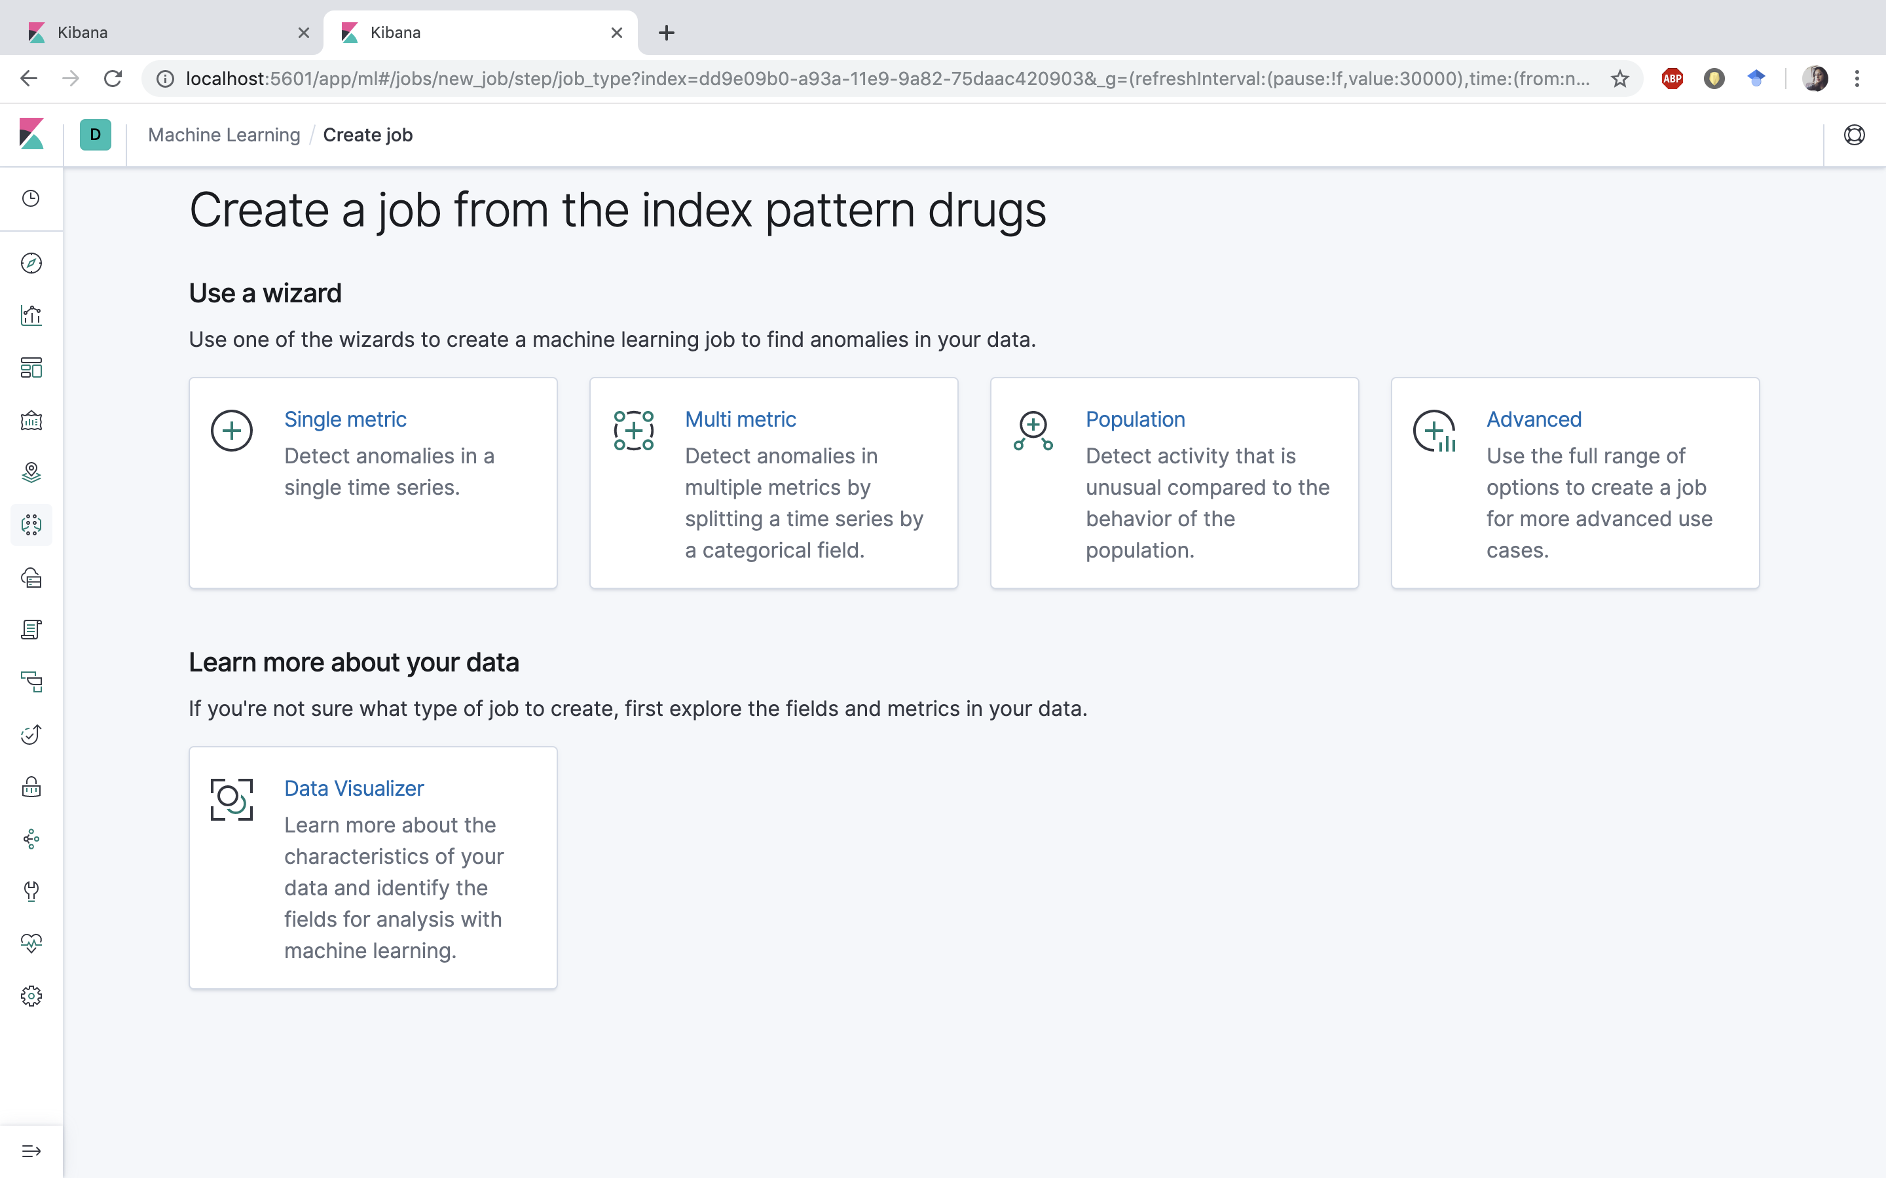

1. Select Mean in Aggregation, rating in Field and put 1d in Bucket Span and click on Use full drugs data. It will show the average rating over the years. You will get a chart similar to this:

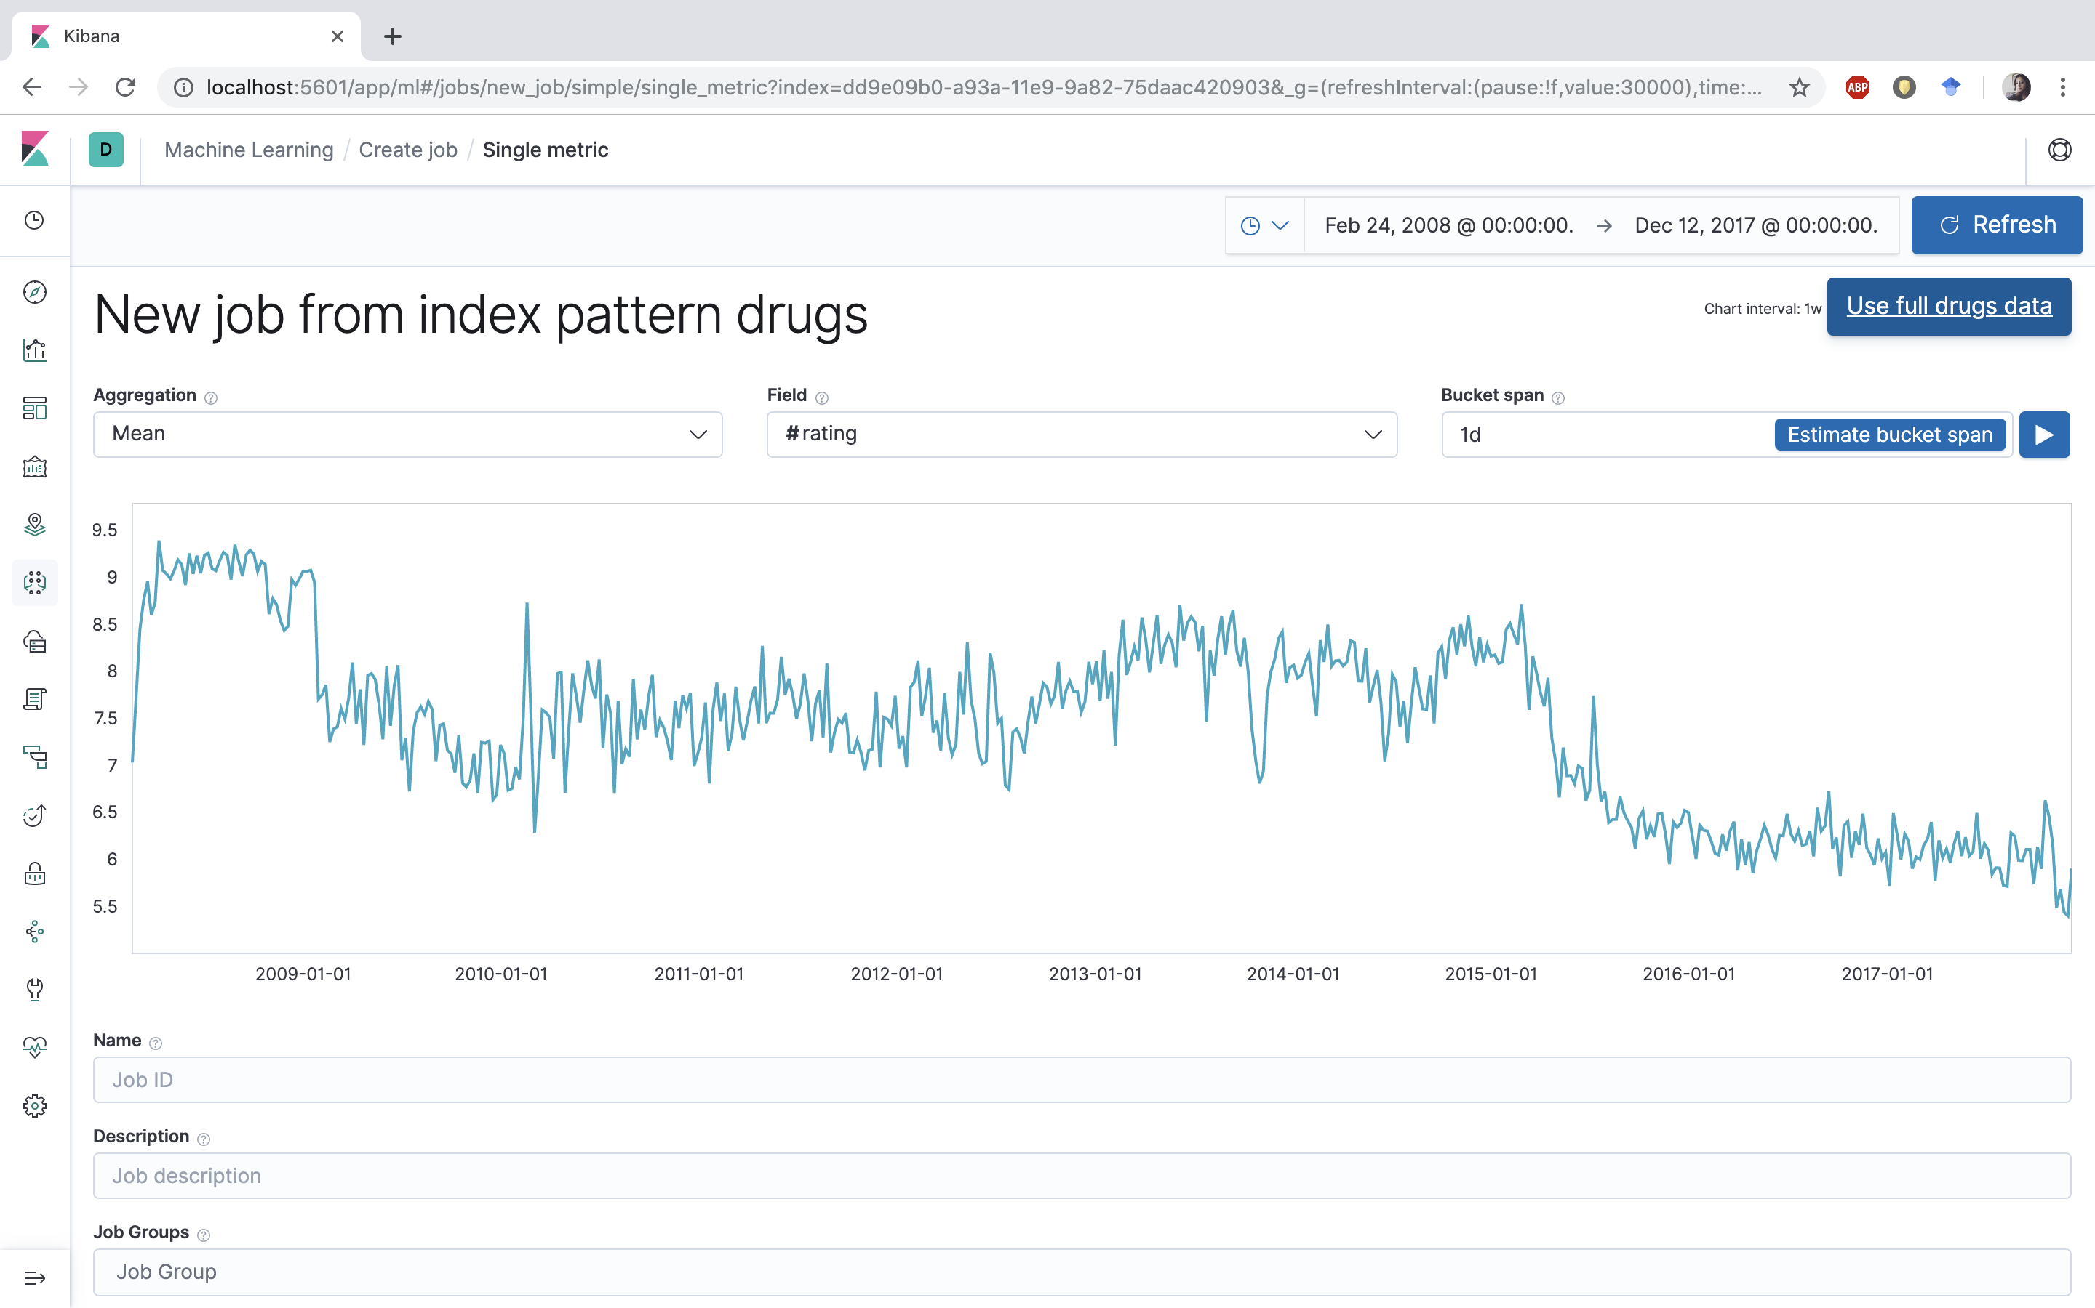

1. Put **ratingDrug** as **Name**, **rating** as **Description** and **rating** as **Job Groups** and click on **Create Job**.

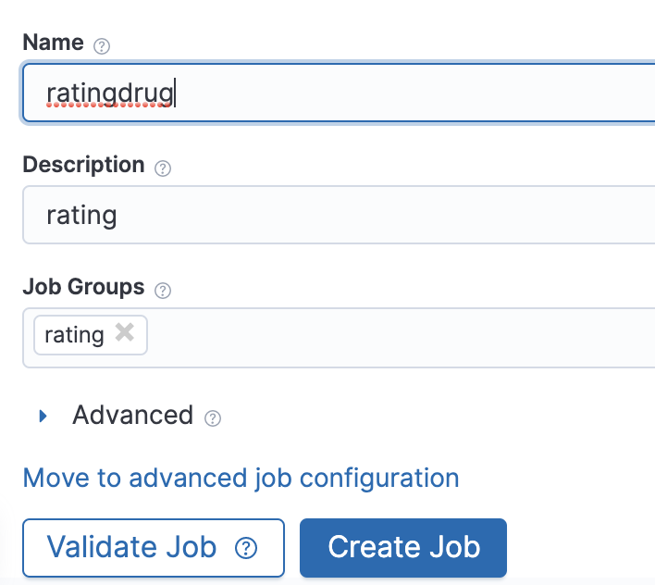

1. It will take some time to create the job. Once the job is created, you can click on the **View Results** button to check the result.

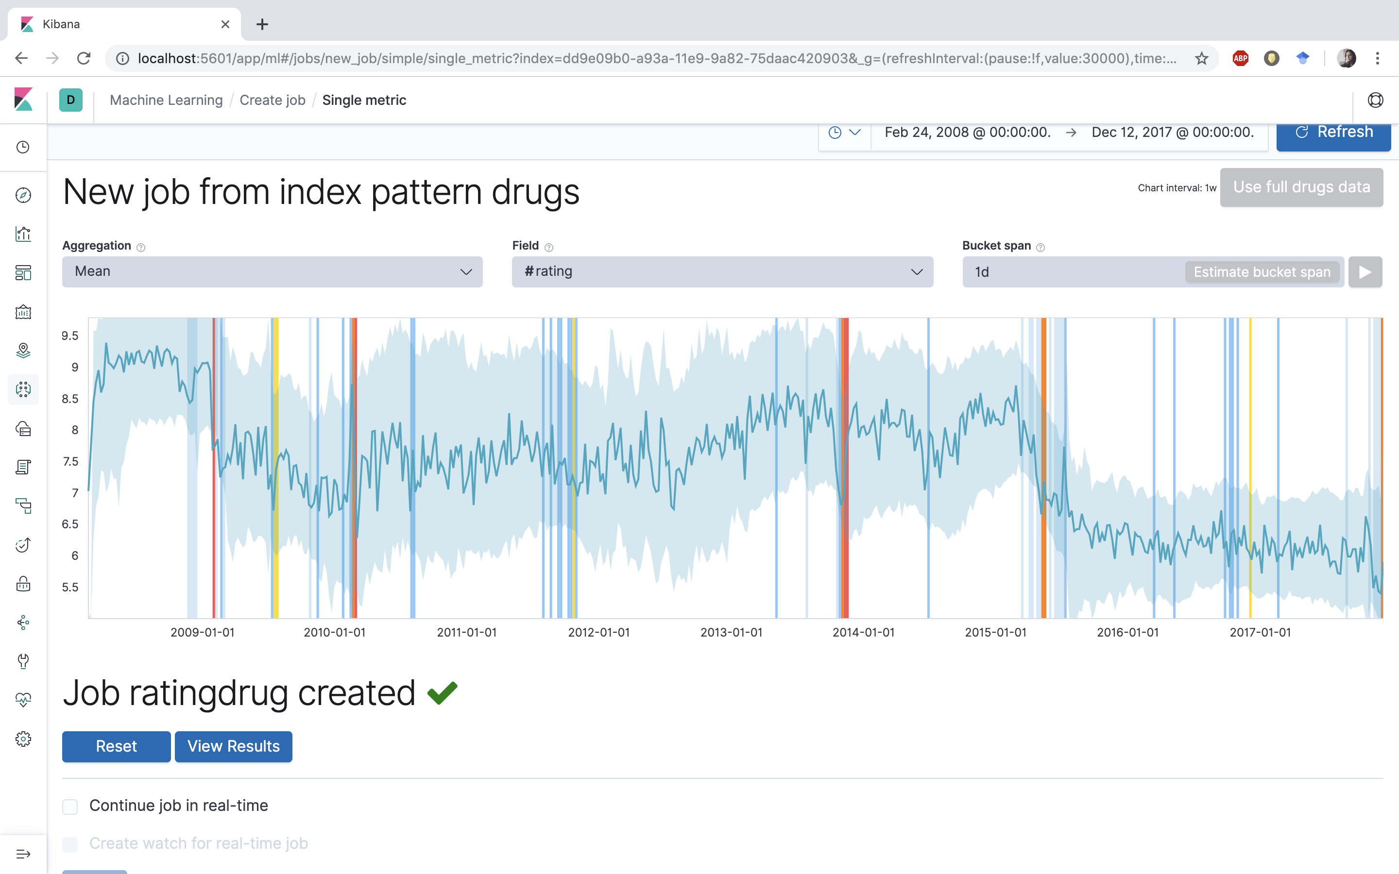

1. The result shows the anomaly detected. The blue line below shoes the average rating of the drugs. The upper and lower bound is shown by the blue shaded region. You can see the severity in threshold by selecting drop down **Severity threshold**. Red is for critical; Orange is for major anomaly and so on.

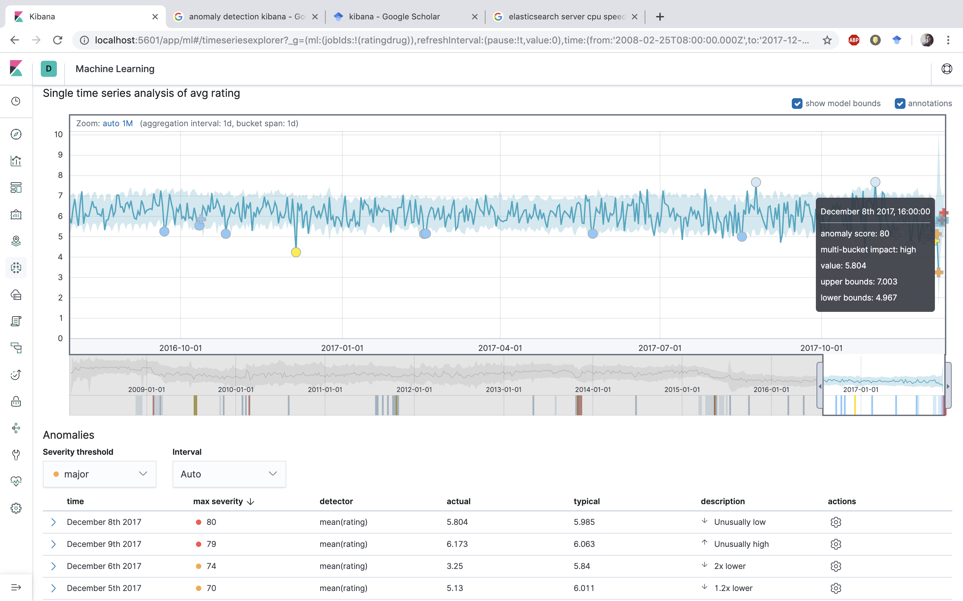

1. You can click on the Forecast button at the upper right corner to forecast the average rating. Click on the Forecast button and run with duration as 104w.

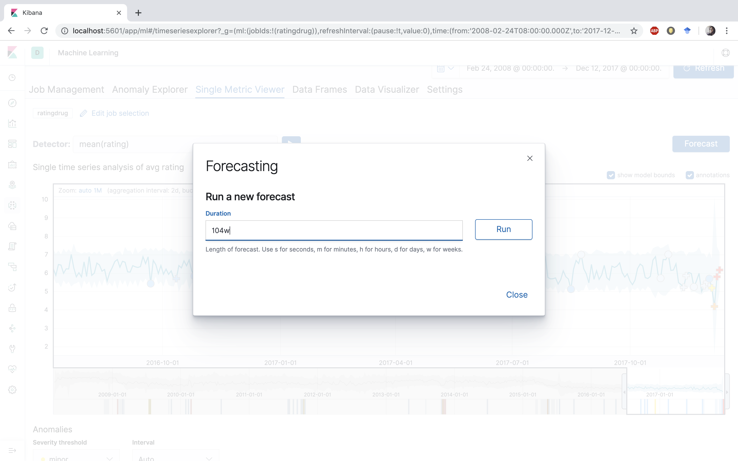

1. It will take few seconds to create the forecasting.

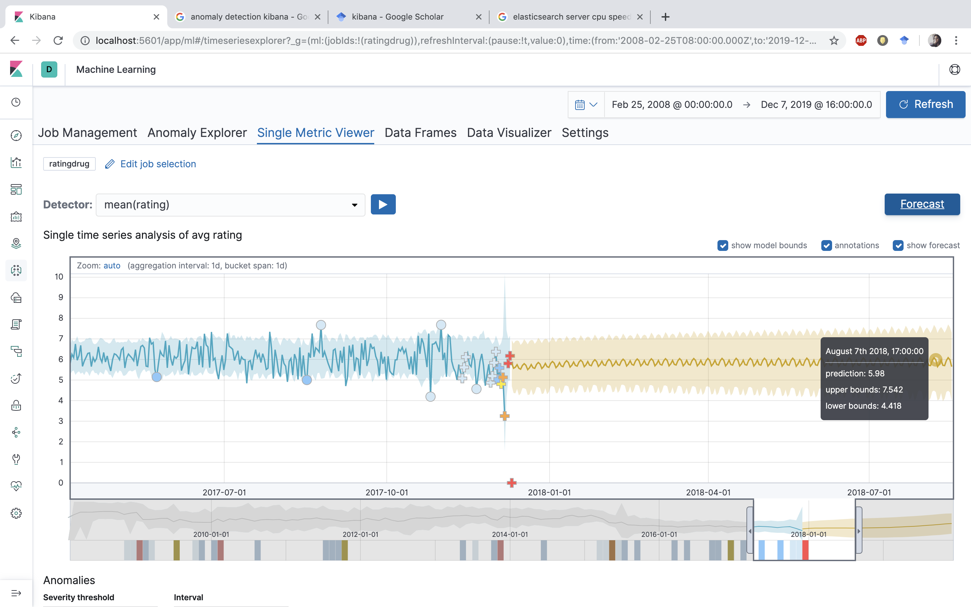

It will show you the forecast result in yellow line. The shaded yellow region is the upper and lower bounds for average rating. You can hover over to see the details. This shows the forecast of the average rating.

**References**

1. https://www.youtube.com/watch?v=wJVgh5knV4E
2. Github Link: https://github.com/monika2403/mmishra2/tree/master/CIS%205560
3. Dataset Link: https://archive.ics.uci.edu/ml/datasets/Drug+Review+Dataset+%28Drugs.com%29
4. Gräßer, F., Kallumadi, S., Malberg, H., & Zaunseder, S. (2018, April). Aspect-based sentiment analysis of drug reviews applying cross-domain and cross-data learning. In *Proceedings of the 2018 International Conference on Digital Health* (pp. 121-125). ACM.